

T.Y.BSc. [COMPUTER SCIENCE]

Seat Number [ **05** ]

Deccan Education Society’s

Kirti College of Arts, Science and Commerce

Deccan Education Society’s

Kirti M. Doongursee College

Of

Arts, Science and Commerce

CERTIFICATE

This is to certify, Mr. / Ms. _____________________________________________

Seat No._______, studying in TYBSC (SEM-VI) Computer Science has satisfactorily

completed the Project with the titled “____________________________________

__________________________________________________________________”

As prescribed by University of Mumbai, during the academic year 2018-19.

______________ ___________________

**(Project In-charge) (H.O.D. CS & IT Dept)**

**__________________**

**(External Examiners)**

A PROJECT REPORT

ON

“_____________________________________”

SUBMITTED BY

_______________

UNDER THE GUIDENCE OF

MRS. AKSHATA NAYAK

TOWARDS THE PARTIALLY FULFILLMENT OF THE

REQUIREMENTS FOR

QUALIFYING

TYBSC (COMPUTER SCIENCE)

SEMESTER VI EXAMINATION

APRIL 2019

SUBMITTED TO

Deccan Education Society’s

Kirti College of Arts, Science and Commerce



|  |  |
| --- | --- |
| Serial  No. | Pages |
| **1.** | **Title** |
| **2.** | **Introduction** |
| **3.** | **Preliminary Investigation and Background** |
| **4.** | **System Analysis** |
| **5.** | **Advantages** |
| **6.** | **Proposed System** |
| **7.** | **Existing System** |
| **8.** | **Requirement Specification** |
| **9.** | **System Design Details(ER Diagram, Data Flow Diagram, Use Case Diagram)** |
| **10** | **System Implementation(Code)** |
| **11.** | **Result(Containing Database tables, Screenshots)** |
| **12.** | **Conclusion** |
| **13.** | **Reference** |

* PREFERENCE

This project aims at computerization of Online Examination Website. These website is developed for conducting exams of students and also take practice of their subject and to maintain the records by using database.

This project is used to reduce manual work behind online examination. The online examination helps student for better knowledge about any programming language.

**MISS. SIDDHI SURESH CHAVAN.**

* ACKNOLEGDEMENT

I’m very grateful to all the individuals who helped me in developing this project. It gives me great pleasure to express my deep sense of gratitude to my External and Internal Project Guides, **Prof. AKSHATA NAYAK**, who offered her suggestion and ideas while developing this project.

I’m thankful to honorable Principle **Dr. D.V.Pawar** Head of Department **Prof. Apurva Yadav**. I appreciate the efforts and assistance provided by Teaching staff and Non-teaching staff of B.sc. CS Department for providing their valuable time and expertise in the making of this project. My senior thanks to all the people who have helped me directly or indirectly in this project.

I’m also very thankful for introducing project and seminar as a subject in syllabus due to which I got acquainted to the various aspect of Software development.

**Sincerely Thanks From,**

**Miss. Siddhi Suresh Chavan.**

**Online Examination Website**

* Introduction:

On-line examinations contents providers to focus on creating effective assessment questions and focusing on exam’s feedback delivery to students. In this we present techniques that are pertinent to the elements of assessment process: answers submission, computerized grading, and feedback after submission.

As the modern organizations are automated and computers are working as per the instructions, it is becomes essential for the coordination of human beings, commodity and computers in a modern organization.

The administrators, instructor, students who are attending for online examination can communicate with the system through this projects, thus facilitating effective implementation and monitoring of various activities of Online Examinations like conducting Exams as per scheduled basis and delivering result to that particular user or student . And the details of students who attempted Online Examination are maintained at administrator.

* **Preliminary investigation and background:**

As the name of the project “On-Line Examination” suggests, the system/application has to manage the examination for various department of an academy. So to keep the information correct and fast, it will manage the status/information of that examination of that exam so one can get the details and structure of exam as per their program.

Earlier it was a very time consuming and tedious process where both students as well as university used to perform all tasks manually be it Student Registration, Setting Question Papers, Setting Schedules to finally declaring the result. It was still not that much simpler Later the process became a so much easier when computer system were introduced. All for students because they were still expected to come to register, appear for exam at exam center and for all those formalities. Now we are expected to develop a web application which converts all of these tasks atomized as well as web enabled.

* System Analysis:

System analysis is a process of gathering and interpreting facts, examination problems and the information about the Online Examination Website System to recommend improvements on the system. It’s a problem solving activity that requires intensive communication between the system users and system developers.

System analysis is an important phase of any system development process. The system is studied to the minutest details. The system analyst plays role of the interrogator and works deep into the working of the present system. The system is view as a whole and the input to the system are identified.

System analysis is concerned with becoming aware of the problems, identifying the relevant, analyzing and synthesizing the various factors and determining an optimal or at least a satisfactory solution or program of action.

* Advantages:

This website reduces the manual work, maintaining accuracy, increasing efficiency and saving time. Also for students it saves time of going too far away centers and also they can view their result then and there.

* Proposed System:

1. Security of data.
2. Ensure data accuracy’s.
3. Greater efficiency.
4. Better service.
5. Minimum time required.

* Existing System:

1. Lack of security data.
2. More man power.
3. Time consuming.
4. Needs manual calculation.

* FronteNd:

ASP.NET

* Backend:

MySQL database

* Requirements for Software Components:

|  |  |
| --- | --- |
| Name of Component | Specification |
| Operating System | Windows 10 |
| Language | C# |
| Database | MySQL Server |
| Browser | Chrome |

* Requirements for Hardware Components:

|  |  |
| --- | --- |
| Name of component | Specification |
| Processor | X64-based processor |
| RAM | 8.00 GB |
| Hard Disk | 99.5 GB |
| Monitor | 17”color monitor |
| Keyboard | 80 Keys |

* Scope of the project:

1. It satisfies the user requirement.
2. Be expandable.
3. Easy to operate.
4. Be easy to understand by the user and operator.
5. Have a good user interface.

* ER Diagram:

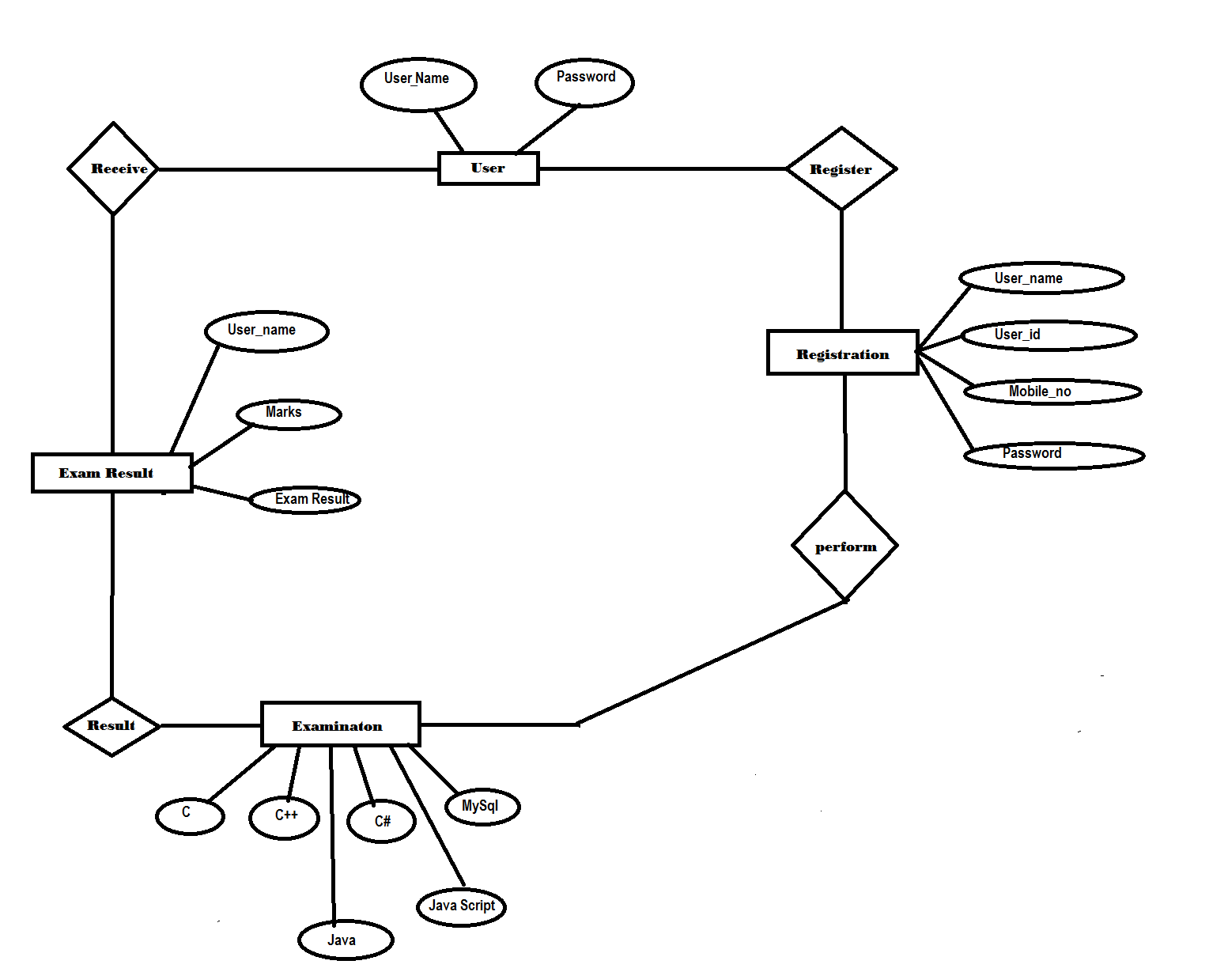

* Data Flow Diagram:

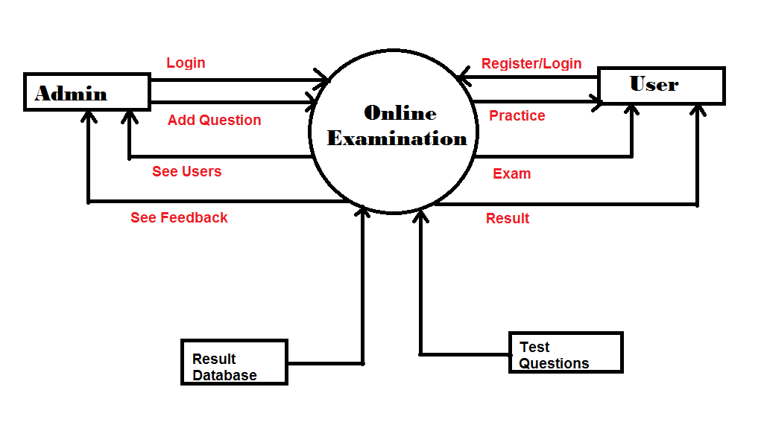

* UCD(Use Case Diagram):

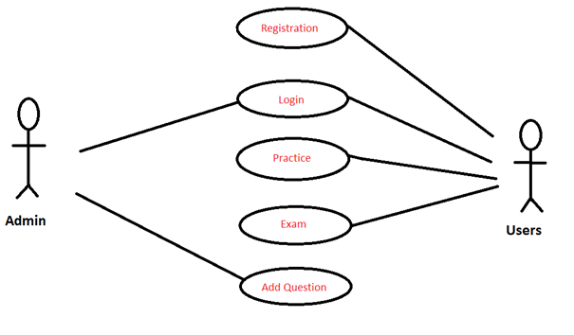

* System Design:

1. Primary Design Phase:

In this phase, the system is designed at block level.

1. Secondary Design Phase:

In this phase, the detailed design of every block is performed.

* Features of the project:

1. Query Issue List to any depth.
2. Simple Status & Resolution.
3. Multi-level Priorities & Severities.
4. Robust database back-end.
5. Accuracy in work.
6. Well design Exams.
7. Works become very speedy.
8. Easy to update information.

* Design of the Pages:

1. Home1:

<%@ Page Title="" Language="C#" MasterPageFile="~/MasterPage.master" AutoEventWireup="true" CodeFile="Home.aspx.cs" Inherits="Home" %>  
  
  
<asp:Content ID="Content1" ContentPlaceHolderID="title" runat="Server">  
    Home  
</asp:Content>  
<asp:Content ID="Content2" ContentPlaceHolderID="head" runat="Server">  
    <%-- ------ CSS ------ --%>  
    <link href="css/bootstrap.min.css" rel="stylesheet" type="text/css" />  
    <link href="css/font-awesome.min.css" rel="stylesheet" type="text/css" />  
    <link href="css/animate.min.css" rel="stylesheet" type="text/css" />  
    <link href="css/prettyPhoto.css" rel="stylesheet" type="text/css" />  
    <link href="css/main.css" rel="stylesheet" type="text/css" />  
    <link href="css/responsive.css" rel="stylesheet" type="text/css" />  
    <link href="http://maxcdn.bootstrapcdn.com/font-awesome/4.2.0/css/font-awesome.min.css"  
        rel="stylesheet" type="text/css" />  
  
  
  
    <!--<if lt IE 9>>  
    <script src="js/html5shiv.js"></script>  
    <script src="js/respond.min.js"></script>  
    <!<endif>-->  
    <script src="js/jquery.js" type="text/javascript"></script>  
    <script src="js/bootstrap.min.js" type="text/javascript"></script>  
    <script src="js/jquery.prettyPhoto.js" type="text/javascript"></script>  
    <script src="js/jquery.isotope.min.js" type="text/javascript"></script>  
    <script src="js/main.js" type="text/javascript"></script>  
    <script src="js/wow.min.js" type="text/javascript"></script>  
    <style type="text/css">  
    .aboutSection  
    {  
        background-color:Silver;  
    }  
    .img  
    {  
        height:100px;  
        width:100px;  
        right:400px;  
    }  
    #p1  
    {  
        height:70px;  
    }  
        .style1  
        {  
            left: 0px;  
            top: 0px;  
        }  
    </style>  
</asp:Content>  
<asp:Content ID="Content3" ContentPlaceHolderID="body" runat="Server">  
    <section id="main-slider" class="no-margin">  
        <div class="carousel slide" data-ride="carousel">  
            <ol class="carousel-indicators">  
                <li data-target="#main-slider" data-slide-to="0" class="active"></li>  
                <li data-target="#main-slider" data-slide-to="1"></li>  
                <li data-target="#main-slider" data-slide-to="2"></li>  
                <li data-target="#main-slider" data-slide-to="3"></li>  
                <li data-target="#main-slider" data-slide-to="4"></li>  
                <li data-target="#main-slider" data-slide-to="5"></li>  
            </ol>  
            <div class="carousel-inner">  
  
                <div class="item active" style="background-image: url(images/slider/bg1.jpg)">  
                    <div class="container">  
                        <div class="row slide-margin">  
                            <div class="col-sm-6">  
                                <div class="carousel-content">  
                                    <h1 class="animation animated-item-1">What is C Programming?</h1>  
                                    <h2 class="animation animated-item-2">C was originally developed by Dennis Ritchie between 1969 and 1973 at Bell Labs,and used to re-implement the Unix operating system.It has since become one of the most widely used programming languages of all time.Unix was one of the first operating system kernels implemented in a language other than assembly.</h2>  
                                    <a class="btn-slide animation animated-item-3" href="SignIn.aspx">Read More</a>  
                                </div>  
                            </div>  
  
                            <div class="col-sm-6 hidden-xs animation animated-item-4">  
                                <div class="slider-img">  
                                    <img src="images/slider/C.png" class="img-responsive">  
                                </div>  
                            </div>  
  
                        </div>  
                    </div>  
                </div><!--/.item-->  
  
                <div class="item" style="background-image: url(images/slider/bg2.jpg)">  
                    <div class="container">  
                        <div class="row slide-margin">  
                            <div class="col-sm-6">  
                                <div class="carousel-content">  
                                    <h1 class="animation animated-item-1">What is C++?</h1>  
                                    <h2 class="animation animated-item-2">C++ is a general-purpose programming language. It has imperative, object-oriented and generic programming features, while also providing facilities for low-level memory manipulation.</h2>  
                                    <a class="btn-slide animation animated-item-3" href="SignIn.aspx">Read More</a>  
                                </div>  
                            </div>  
  
                            <div class="col-sm-6 hidden-xs animation animated-item-4">  
                                <div class="slider-img">  
                                    <img src="images/slider/Cpp.png" class="img-responsive">  
                                </div>  
                            </div>  
  
                        </div>  
                    </div>  
                </div><!--/.item-->  
  
                <div class="item" style="background-image: url(images/slider/bg3.jpg)">  
                    <div class="container">  
                        <div class="row slide-margin">  
                            <div class="col-sm-6">  
                                <div class="carousel-content">  
                                    <h1 class="animation animated-item-1">What is Java?</h1>  
                                    <h2 class="animation animated-item-2">Java is a general-purpose computer programming language that is concurrent, class-based, object-oriented, and specifically designed to have as few implementation dependencies as possible. It is intended to let application developers "write once, run anywhere" (WORA)</h2>  
                                    <a class="btn-slide animation animated-item-3" href="SignIn.aspx">Read More</a>  
                                </div>  
                            </div>  
                            <div class="col-sm-6 hidden-xs animation animated-item-4">  
                                <div class="slider-img">  
                                    <img src="images/slider/java.png" class="img-responsive">  
                                </div>  
                            </div>  
                        </div>  
                    </div>  
                </div><!--/.item-->  
  
  
                  
                <div class="item" style="background-image: url(images/slider/sbgimg4.jpg)">  
                    <div class="container">  
                        <div class="row slide-margin">  
                            <div class="col-sm-6">  
                                <div class="carousel-content">  
                                    <h1 class="animation animated-item-1">What is JavaScript?</h1>  
                                    <h2 class="animation animated-item-2">JavaScript is a high-level, dynamic, untyped, and interpreted programming language.It has been standardized in the ECMAScript language specification.Alongside HTML and CSS, JavaScript is one of the three core technologies of World Wide Web content production, the majority of websites employ it.</h2>  
                                    <a class="btn-slide animation animated-item-3" href="SignIn.aspx">Read More</a>  
                                </div>  
                            </div>  
  
                            <div class="col-sm-6 hidden-xs animation animated-item-4">  
                                <div class="slider-img">  
                                    <img src="images/slider/Javascript.png" class="img-responsive">  
                                </div>  
                            </div>  
  
                        </div>  
                    </div>  
                </div><!--/.item-->  
  
  
  
                  
                <div class="item" style="background-image: url(images/slider/sbgimg5.jpg)">  
                    <div class="container">  
                        <div class="row slide-margin">  
                            <div class="col-sm-6">  
                                <div class="carousel-content">  
                                    <h1 class="animation animated-item-1">What is C#?</h1>  
                                    <h2 class="animation animated-item-2">C# is a simple, modern, general-purpose, object-oriented programming language developed by Microsoft within its .NET initiative led by Anders Hejlsberg. This tutorial will teach you basic C# programming and will also take you through various advanced concepts related to C# programming language.</h2>  
                                    <a class="btn-slide animation animated-item-3" href="SignIn.aspx">Read More</a>  
                                </div>  
                            </div>  
  
                            <div class="col-sm-6 hidden-xs animation animated-item-4">  
                                <div class="slider-img">  
                                    <img src="images/slider/CSharp.png" class="img-responsive">  
                                </div>  
                            </div>  
  
                        </div>  
                    </div>  
                </div><!--/.item-->  
  
  
  
                  
                <div class="item" style="background-image: url(images/slider/sbgimg6.jpg)">  
                    <div class="container">  
                        <div class="row slide-margin">  
                            <div class="col-sm-6">  
                                <div class="carousel-content">  
                                    <h1 class="animation animated-item-1">What is MySql?</h1>  
                                    <h2 class="animation animated-item-2">MySQL is the most popular Open Source Relational SQL database management system. MySQL is one of the best RDBMS being used for developing web-based software applications.</h2>  
                                    <a class="btn-slide animation animated-item-3" href="SignIn.aspx">Read More</a>  
                                </div>  
                            </div>  
  
                            <div class="col-sm-6 hidden-xs animation animated-item-4">  
                                <div class="slider-img">  
                                    <img src="images/slider/MySQL.png" class="img-responsive">  
                                </div>  
                            </div>  
  
                        </div>  
                    </div>  
                </div><!--/.item-->  
            </div><!--/.carousel-inner-->  
        </div><!--/.carousel-->  
        <a class="prev hidden-xs" href="#main-slider" data-slide="prev">  
            <i class="fa fa-chevron-left"></i>  
        </a>  
        <a class="next hidden-xs" href="#main-slider" data-slide="next">  
            <i class="fa fa-chevron-right"></i>  
        </a>  
    </section>  
    <!--/#main-slider-->  
  
    <!--Subjects-->  
    <div class="container">  
        <div class="row">  
            <div class="col-lg-12">  
                <h2>  
                    What should you know before starting Practice and Exam?</h2>  
            </div>  
        </div>  
        <div class="row">  
            <div class="col-lg-4 col-md-3 col-sm-6">  
                <a href="" class="thumbnail">  
                    <p>  
                        C Programming</p>  
                    <img src="images/slider/C.png" />  
                </a>  
            </div>  
            <div class="col-lg-4 col-md-3 col-sm-6">  
                <a href="SignIn.aspx" class="thumbnail">  
                    <p>  
                        C++</p>  
                    <img src="images/Cpp.png" />  
                </a>  
            </div>  
            <div class="col-lg-4 col-md-3 col-sm-6">  
                <a href="SignIn.aspx" class="thumbnail">  
                    <p>  
                        Java</p>  
                    <img src="images/java.png" />  
                </a>  
            </div>  
        </div>  
        <div class="row">  
            <div class="col-lg-4 col-md-4 col-sm-6">  
                <a href="SignIn.aspx" class="thumbnail">  
                    <p>  
                        JavaScript</p>  
                    <img src="images/slider/Javascript.png" />  
                </a>  
            </div>  
            <div class="col-lg-4 col-md-4 col-sm-6">  
                <a href="SignIn.aspx" class="thumbnail">  
                    <p>  
                        MySql</p>  
                    <img src="images/MySQL.png" />  
                </a>  
            </div>  
            <div class="col-lg-4 col-md-4 col-sm-6">  
                <a href="SignIn.aspx" class="thumbnail">  
                    <p>  
                        C#</p>  
                    <img src="images/CSharp.png" />  
                </a>  
            </div>  
        </div>  
    </div>  
    </div>  
    <!--Programmin langugge used-->  
    <div>      
    <section id="middle">  
        <div class="container">  
            <div class="row">  
                <div class="style1">  
                    <div class="skill" id="p1">  
                        <h2>Use of Programming and Scripting languages in present Time(2016-17)</h2>  
                          
                        <div class="progress-wrap">  
                            <h3>SQL</h3>  
                            <div class="progress">  
                              <div class="progress-bar  color1" role="progressbar" aria-valuenow="40" aria-valuemin="0" aria-valuemax="100" style="width: 90%">  
                                <span class="bar-width">90%</span>  
                              </div>  
  
                            </div>  
                        </div>  
  
                        <div class="progress-wrap">  
                            <h3>JAVA</h3>  
                            <div class="progress">  
                              <div class="progress-bar color2" role="progressbar" aria-valuenow="20" aria-valuemin="0" aria-valuemax="100" style="width: 84%">  
                               <span class="bar-width">84%</span>  
                              </div>  
                            </div>  
                        </div>  
  
                        <div class="progress-wrap">  
                            <h3>JavaScript</h3>  
                            <div class="progress">  
                              <div class="progress-bar color3" role="progressbar" aria-valuenow="60" aria-valuemin="0" aria-valuemax="100" style="width: 80%">  
                                <span class="bar-width">80%</span>  
                              </div>  
                            </div>  
                        </div>  
  
                        <div class="progress-wrap">  
                            <h3>C#</h3>  
                            <div class="progress">  
                              <div class="progress-bar color4" role="progressbar" aria-valuenow="80" aria-valuemin="0" aria-valuemax="100" style="width: 58%">  
                                <span class="bar-width">58%</span>  
                              </div>  
                            </div>  
                        </div>  
  
                        <div class="progress-wrap">  
                            <h3>Python</h3>  
                            <div class="progress">  
                              <div class="progress-bar color2" role="progressbar" aria-valuenow="20" aria-valuemin="0" aria-valuemax="100" style="width: 45%">  
                               <span class="bar-width">45%</span>  
                              </div>  
                            </div>  
                        <div class="progress-wrap">  
  
                          
                        <div class="C++">  
                            <h3>JAVA</h3>  
                            <div class="progress">  
                              <div class="progress-bar color2" role="progressbar" aria-valuenow="20" aria-valuemin="0" aria-valuemax="100" style="width: 40%">  
                               <span class="bar-width">40%</span>  
                              </div>  
                            </div>  
                        </div>  
  
                        <div class="progress-wrap">  
                            <h3>pHp</h3>  
                            <div class="progress">  
                              <div class="progress-bar color3" role="progressbar" aria-valuenow="60" aria-valuemin="0" aria-valuemax="100" style="width: 35%">  
                                <span class="bar-width">35%</span>  
                              </div>  
                            </div>  
                        </div>  
  
                        <div class="progress-wrap">  
                            <h3>IOS</h3>  
                            <div class="progress">  
                              <div class="progress-bar color4" role="progressbar" aria-valuenow="80" aria-valuemin="0" aria-valuemax="100" style="width: 28%">  
                                <span class="bar-width">28%</span>  
                              </div>  
                            </div>  
                        </div>  
  
                        <div class="progress-wrap">  
                            <h3>RUBY/RAILS</h3>  
                            <div class="progress">  
                              <div class="progress-bar color2" role="progressbar" aria-valuenow="20" aria-valuemin="0" aria-valuemax="100" style="width: 10%">  
                               <span class="bar-width">10%</span>  
                              </div>  
                            </div>  
                        </div>  
                        </div>  
  
                    </div>  
  
                </div><!--/.col-sm-6-->  
                </div>  
                </div>  
                </div>  
                </section>  
                </div>  
  
  
  
    <footer class="row back aboutSection">  
        <div class="container" id="aboutSection">  
            <div  class="col-md-3 col-sm-6 col-xs-12">  
                <h3>About Us</h3>  
<img src="images/my_img.jpg" class="img-circle img" />  
                  
                    <p>Myself Vishal V. Upadhyay</p>  
                <p>Currently I'm Studend and hosting ProgrmmingSkills.com website</p>  
                  
                    <p>My Blogspot:</p>  
                    <p><a href="www.vishalprogrammingskills.blogspot.in">Programming Skills</a></p>  
                  
                    <p>My Youtube Channel:</p>  
                    <a href="#">Programming Skills</a>  
                  
              
            </div>  
            <div  class="col-md-3 col-sm-6 col-xs-12">  
                <h3>Our Vision</h3>  
                  
<img src="images/vision.jpg" class="img-circle img" />  
                <div class="one_tweet">  
                    <p>To provide you a platform where you can enhance your programmming skills</p>  
                      
                </div>  
                <div class="one_tweet">  
                    <p>To make you comfortable with languages by knowing their different kinds of Questions</p>  
                </div>  
                      
                <div class="one_tweet">  
                    <p>To Certifed you in your knlowledged programming language</p>  
                </div>  
            </div>  
              
            <div  class="col-md-3 col-sm-6 col-xs-12">  
                <h3>Contact us</h3>  
                  
<img src="images/contactus.jpg"  class="img-circle img" />  
                <p>  uvvishalupadhyay@gmail.com</p>  
                <p>  www.vishalprogrammingskills.blogspot.in</p>  
                <p>91-8999999911</p>  
          
            </div>  
            <div  class="col-md-3 col-sm-6 col-xs-12">  
                <h3>Comming Soon</h3>  
                  
<img src="images/coming soon.jpg"  class="img-circle img" />  
                <div class="one_tweet">  
                <p>We're comming with more languages like pHp,RUBY,Python</p>  
                </div>  
                  
                <div class="one_tweet">  
                    <p>We always keep update the questons so you can get more Idea about questoins</p>  
                </div>  
                  
            </div>  
              
        </div></footer>  
</asp:Content>

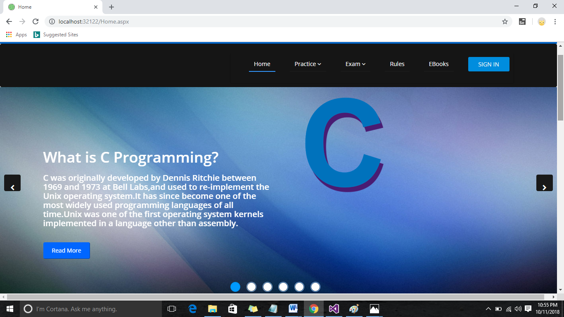

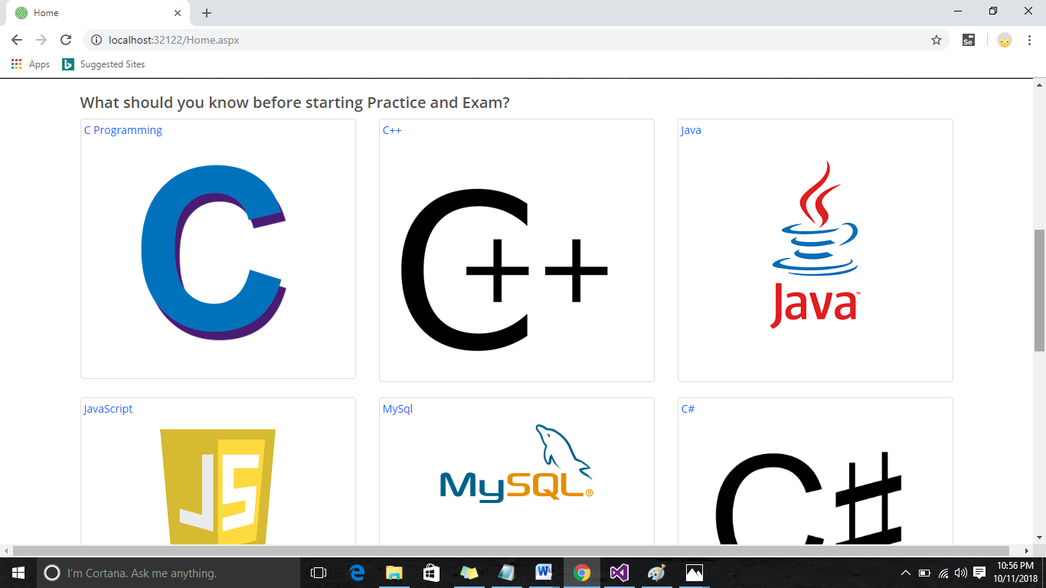

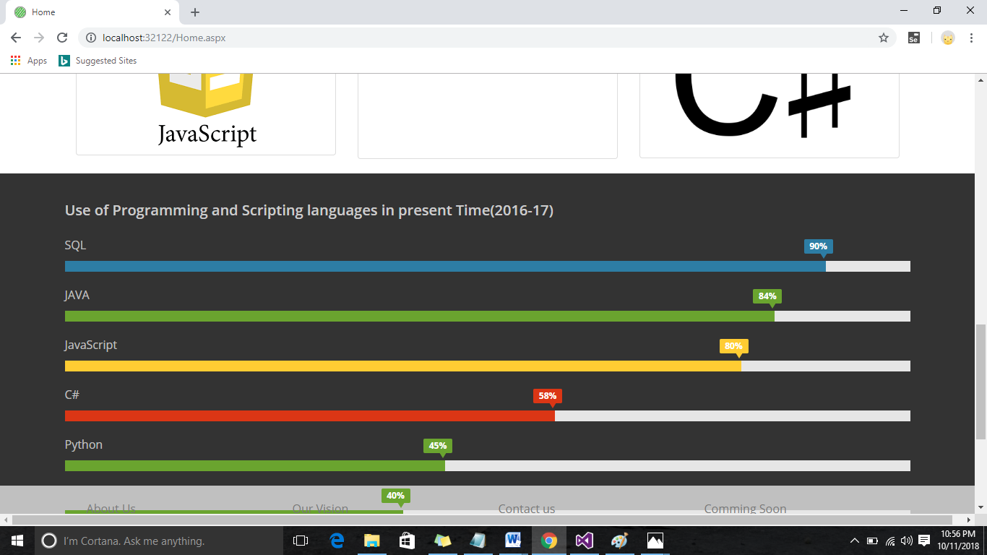

1. Master Page:

<%@ Master Language="C#" AutoEventWireup="true" CodeFile="MasterPage2.master.cs" Inherits="MasterPage2" %>

<!DOCTYPE html>

<html xmlns="http://www.w3.org/1999/xhtml">

<head id="Head1" runat="server">

<title>

<asp:ContentPlaceHolder ID="title" runat="server">

</asp:ContentPlaceHolder>

</title>

<link href="css/bootstrap.min.css" rel="stylesheet" type="text/css" />

<link href="css/font-awesome.min.css" rel="stylesheet" type="text/css" />

<link href="css/animate.min.css" rel="stylesheet" type="text/css" />

<link href="css/prettyPhoto.css" rel="stylesheet" type="text/css" />

<link href="css/main.css" rel="stylesheet" type="text/css" />

<link href="css/responsive.css" rel="stylesheet" type="text/css" />

<link rel="shortcut icon" href="images/logo.png" />

<style type="text/css">

input[type="submit"]

{

background-color: #008dde;

border: none;

border-radius: 3px;

-moz-border-radius: 3px;

-webkit-border-radius: 3px;

color: #f4f4f4;

cursor: pointer;

font-family: 'Open Sans' , Arial, Helvetica, sans-serif;

height: 35px;

text-transform: uppercase;

width: 100px;

-webkit-appearance: none;

}

#name

{

font-size:x-large;

color:Black;

font-family:Segoe Print;

}

#logoimg

{

width:40px;

height:40px;

}

.h

{

float:left;

}

</style>

<asp:ContentPlaceHolder ID="head" runat="server">

</asp:ContentPlaceHolder>

</head>

<body>

<form id="form1" runat="server">

<header id="header">

<div class="top-bar">

<div class="container">

<div class="row">

<div class="col-xs-6 col-sm-6 col-md-6 col-lg-6">

<div class="h">

<img src="images/logo.png" id="logoimg"/>

</div> &nbsp;&nbsp;&nbsp;

<div class="h">

<p id ="name">ProgrammingSkills.com</p>

</div>

<%--

<div class="top-number"><p><i class="fa fa-thumbs-up"></i> Keep In Tounch </p></div>--%>

</div>

<div class="col-xs-6 col-sm-6 col-md-6 col-lg-6">

<div class="social">

<ul class="social-share">

<li><a href="https://www.facebook.com/Programming-Skills-1893624260919861/"><i class="fa fa-facebook"></i></a></li><%--

<li><a href="#"><i class="fa fa-twitter"></i></a></li>--%>

<li><a href="https://www.instagram.com/vishalvupadhyay/"><i class="fa fa-instagram"></i></a></li>

</ul>

</div>

</div>

</div>

</div><%--container--%>

</div><%--/top-bar--%>

<nav class="navbar navbar-inverse nav" role="banner">

<div class="container">

<div class="collapse navbar-collapse navbar-right navbar-toggle">

<ul class="nav navbar-nav">

<li class="active"><a href="HOME2.aspx">Home</a></li>

<li class="dropdown">

<a href="#" class="dropdown-toggle" data-toggle="dropdown">Practice <i class="fa fa-angle-down"></i></a>

<ul class="dropdown-menu">

<li><a href="PracC.aspx">C</a></li>

<li><a href="PracCpp.aspx">C++</a></li>

<li><a href="PracJava.aspx">JAVA</a></li>

<li><a href="PracJavaScript.aspx">JavaScript</a></li>

<li><a href="PracCSharp.aspx">C#</a></li>

<li><a href="MySql.aspx">MySql</a></li>

</ul>

</li>

<li class="dropdown">

<a href="#" class="dropdown-toggle" data-toggle="dropdown">Exam <i class="fa fa-angle-down"></i></a>

<ul class="dropdown-menu">

<li><a href="ExamC.aspx">C</a></li>

<li><a href="ExamCpp.aspx">C++</a></li>

<li><a href="ExamJava.aspx">JAVA</a></li>

<li><a href="ExamJavaScript.aspx">JavaScript</a></li>

<li><a href="ExamCSharp.aspx">C#</a></li>

<li><a href="ExamMySql.aspx">MySql</a></li>

</ul>

</li>

<%--

<li><asp:Button ID="SignOut" runat="server" Text="Sign Out"

onclick="SignOut_Click" CausesValidation="False"></asp:Button></li> --%>

<%--<li class="dropdown">

<a href="#" class="dropdown-toggle" data-toggle="dropdown"><i class="glyphicon glyphicon-cog"></i> <i class="fa fa-angle-down"></i></a>

<ul class="dropdown-menu">

<li style="text-align:center"><asp:Button ID="SignOut" runat="server" Text="Sign Out"

CausesValidation="false" onclick="SignOut_Click"></asp:Button></li>

</ul>

</li>--%>

<li><a href="Rules.aspx">Rules</a></li>

<li><a href="Ebook2.aspx">EBooks</a></li>

<li><asp:Button ID="SignOut" runat="server" Text="Sign Out"

onclick="SignOut_Click" CausesValidation="False"></asp:Button></li>

</ul>

</div>

</div><!--/.container-->

</nav><!--/nav-->

</header>

<div>

<asp:ContentPlaceHolder ID="body" runat="server">

</asp:ContentPlaceHolder>

<footer id="footer" class="midnight-blue">

<div class="container">

<div class="row">

<div class="col-sm-6">

&copy; ProgrammingSkills.com. All Rights Reserved.

</div>

</div>

</div>

</footer>

</div>

</form>

</body>

</html>

1. Login page:

<%@ Page Title="" Language="C#" MasterPageFile="~/MasterPage.master" AutoEventWireup="true" CodeFile="SignIn.aspx.cs" Inherits="SignIn" %>

<asp:Content ID="Content1" ContentPlaceHolderID="title" Runat="Server">

SignIn

</asp:Content>

<asp:Content ID="Content2" ContentPlaceHolderID="head" Runat="Server">

<style type="text/css">

body {

background-color: #f4f4f4;

color: #5a5656;

font-family: 'Open Sans', Arial, Helvetica, sans-serif;

font-size: 16px;

line-height: 1.5em;

}

#a1

{

font-size:x-large;

}

a { text-decoration: none; }

h1 { font-size: 1em; }

h1, p {

margin-bottom: 10px;

}

strong {

font-weight: bold;

}

.uppercase { text-transform: uppercase; }

/* ---------- LOGIN ---------- */

#login {

margin: 50px auto;

width: 300px;

}

form fieldset input[type="text"], input[type="password"] {

background-color: #e5e5e5;

border: none;

border-radius: 3px;

-moz-border-radius: 3px;

-webkit-border-radius: 3px;

color: #5a5656;

font-family: 'Open Sans', Arial, Helvetica, sans-serif;

font-size: 14px;

height: 50px;

outline: none;

padding: 0px 10px;

width: 280px;

-webkit-appearance:none;

}

form fieldset input[type="submit"] {

background-color: #008dde;

border: none;

border-radius: 3px;

-moz-border-radius: 3px;

-webkit-border-radius: 3px;

color: #f4f4f4;

cursor: pointer;

font-family: 'Open Sans', Arial, Helvetica, sans-serif;

height: 50px;

text-transform: uppercase;

width: 280px;

-webkit-appearance:none;

}

form fieldset a {

color: #5a5656;

font-size: 10px;

}

h1

{

color:Black;

}

</style>

</asp:Content>

<asp:Content ID="Content3" ContentPlaceHolderID="body" Runat="Server">

<div id="login">

<h1><strong>Welcome.</strong> Please login.</h1>

<fieldset>

Email ID:<br /><br />

<asp:TextBox ID="emailid" runat="server" ControlToValidate="emailid"></asp:TextBox>

<asp:RequiredFieldValidator ID="RequiredFieldValidator2" runat="server"

ErrorMessage="*" ControlToValidate="emailid" ForeColor="Red"></asp:RequiredFieldValidator>

<asp:RegularExpressionValidator ID="RegularExpressionValidator1" runat="server"

ErrorMessage="email format:abc@xyz.com" ControlToValidate="emailid"

ForeColor="Red"

ValidationExpression="\w+([-+.']\w+)*@\w+([-.]\w+)*\.\w+([-.]\w+)*"></asp:RegularExpressionValidator>

<br /><br />

Password:<br /><br /><asp:TextBox ID="lpassword" runat="server" TextMode="Password"></asp:TextBox>

<asp:RequiredFieldValidator ID="RequiredFieldValidator1" runat="server"

ErrorMessage="*" ControlToValidate="lpassword" ForeColor="Red"></asp:RequiredFieldValidator>

<p><a href="ForgotPassword.aspx">Forgot Password?</a></p>

<p>

<asp:Label ID="Label1" runat="server" ForeColor="#FF3300"></asp:Label>

</p>

<asp:Button ID="Button1" runat="server" Text="Login" onclick="Button1_Click" />

<br /><br />

<p>New User? click Here for</p> <h1> <a href="Registration.aspx" id="a1"> SignUP </a></h1>

</fieldset><br />

<br />

<br />

&nbsp;

</div>

</asp:Content>

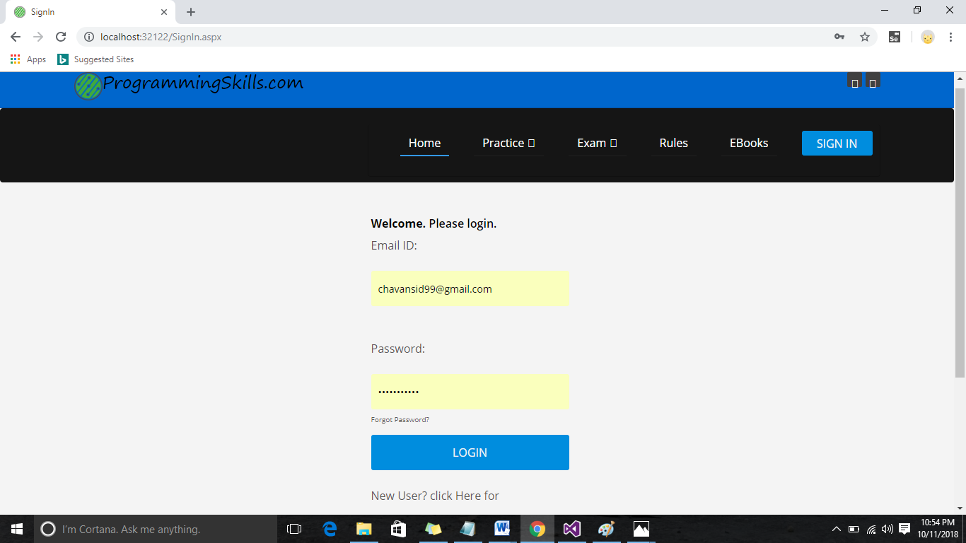

1. Registration:

<%@ Page Title="" Language="C#" MasterPageFile="~/MasterPage.master" AutoEventWireup="true" CodeFile="Registration.aspx.cs" Inherits="Registration" %>

<asp:Content ID="Content1" ContentPlaceHolderID="title" Runat="Server">

Registration

</asp:Content>

<asp:Content ID="Content2" ContentPlaceHolderID="head" Runat="Server">

<style type="text/css">

body {

background-color: #f4f4f4;

color: #5a5656;

font-family: 'Open Sans', Arial, Helvetica, sans-serif;

font-size: 16px;

line-height: 1.5em;

}

a { text-decoration: none; }

h1 { font-size: 1em; }

h1, p {

margin-bottom: 10px;

}

strong {

font-weight: bold;

}

.uppercase { text-transform: uppercase; }

/* ---------- LOGIN ---------- */

#login {

margin: 50px auto;

width: 300px;

}

form fieldset input[type="text"], input[type="password"] {

background-color: #e5e5e5;

border: none;

border-radius: 3px;

-moz-border-radius: 3px;

-webkit-border-radius: 3px;

color: #5a5656;

font-family: 'Open Sans', Arial, Helvetica, sans-serif;

font-size: 14px;

height: 50px;

outline: none;

padding: 0px 10px;

width: 280px;

-webkit-appearance:none;

}

form fieldset input[type="submit"] {

background-color: #008dde;

border: none;

border-radius: 3px;

-moz-border-radius: 3px;

-webkit-border-radius: 3px;

color: #f4f4f4;

cursor: pointer;

font-family: 'Open Sans', Arial, Helvetica, sans-serif;

height: 50px;

text-transform: uppercase;

width: 280px;

-webkit-appearance:none;

}

form fieldset a {

color: #5a5656;

font-size: 10px;

}

h1

{

color:Black;

}

</style>

</asp:Content>

<asp:Content ID="Content3" ContentPlaceHolderID="body" Runat="Server">

<div id="login">

<h1><strong>Welcome.</strong> Please Enter the following details.</h1><br />

<fieldset>

Full Name:<br /><br />

<asp:TextBox ID="name" runat="server"></asp:TextBox>

<asp:RequiredFieldValidator ID="RequiredFieldValidator1" ForeColor="Red" runat="server" ErrorMessage="*" ControlToValidate="name"></asp:RequiredFieldValidator>

<br /><br />

Email Id:<br /><br /><asp:TextBox ID="email" runat="server"></asp:TextBox>

<asp:RequiredFieldValidator ID="RequiredFieldValidator2" ForeColor="Red" runat="server" ErrorMessage="*" ControlToValidate="email"></asp:RequiredFieldValidator>

<br />

<asp:RegularExpressionValidator ID="RegularExpressionValidator1" runat="server"

ControlToValidate="email" ErrorMessage="Email format should be:abc@xyz.com"

ForeColor="Red"

ValidationExpression="\w+([-+.']\w+)*@\w+([-.]\w+)*\.\w+([-.]\w+)*"></asp:RegularExpressionValidator>

<br />

Mobile Number:<br /><br /><asp:TextBox ID="mobile" runat="server"></asp:TextBox>

<asp:RequiredFieldValidator ID="RequiredFieldValidator3" ForeColor="Red" runat="server" ErrorMessage="*" ControlToValidate="mobile"></asp:RequiredFieldValidator>

<br /><br />

Password:<br /><br /><asp:TextBox ID="password" runat="server" TextMode="Password"></asp:TextBox>

<asp:RequiredFieldValidator ID="RequiredFieldValidator4" ForeColor="Red" runat="server" ErrorMessage="*" ControlToValidate="password"></asp:RequiredFieldValidator>

Confirm Password:<br /><br /> <asp:TextBox ID="cpassword" runat="server" TextMode="Password"></asp:TextBox>

<asp:RequiredFieldValidator ID="RequiredFieldValidator5" ForeColor="Red" runat="server" ErrorMessage="*" ControlToValidate="cpassword"></asp:RequiredFieldValidator>

<asp:CompareValidator ID="CompareValidator1" runat="server"

ErrorMessage="Password is not matching" ControlToCompare="cpassword"

ControlToValidate="password" ForeColor="Red"></asp:CompareValidator>

<br /><br />

<asp:TextBox ID="user_type" runat="server" Enabled="False" ForeColor="Green"

Visible="False">Normal User</asp:TextBox>

<asp:RequiredFieldValidator ID="RequiredFieldValidator6" ForeColor="Red" runat="server" ErrorMessage="*" ControlToValidate="user_type"></asp:RequiredFieldValidator>

<br /><br />

<asp:Button ID="Button2" runat="server" Text="Sign Up"

onclick="Button2_Click" />

<br />

<br />

</fieldset><br />

<br />

<br />

<asp:Label ID="Label1" runat="server" Text=""></asp:Label>

</div>

</asp:Content>

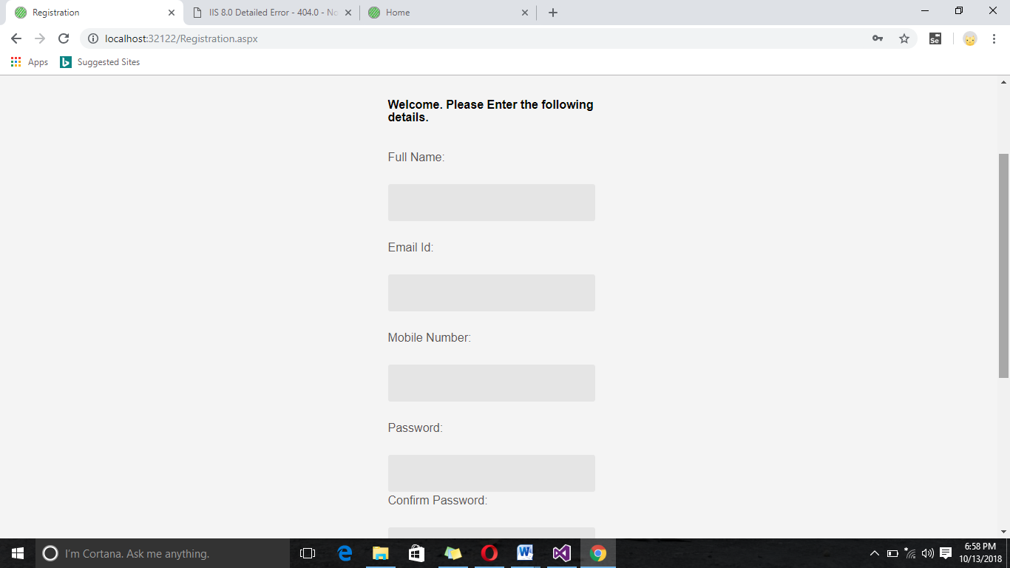

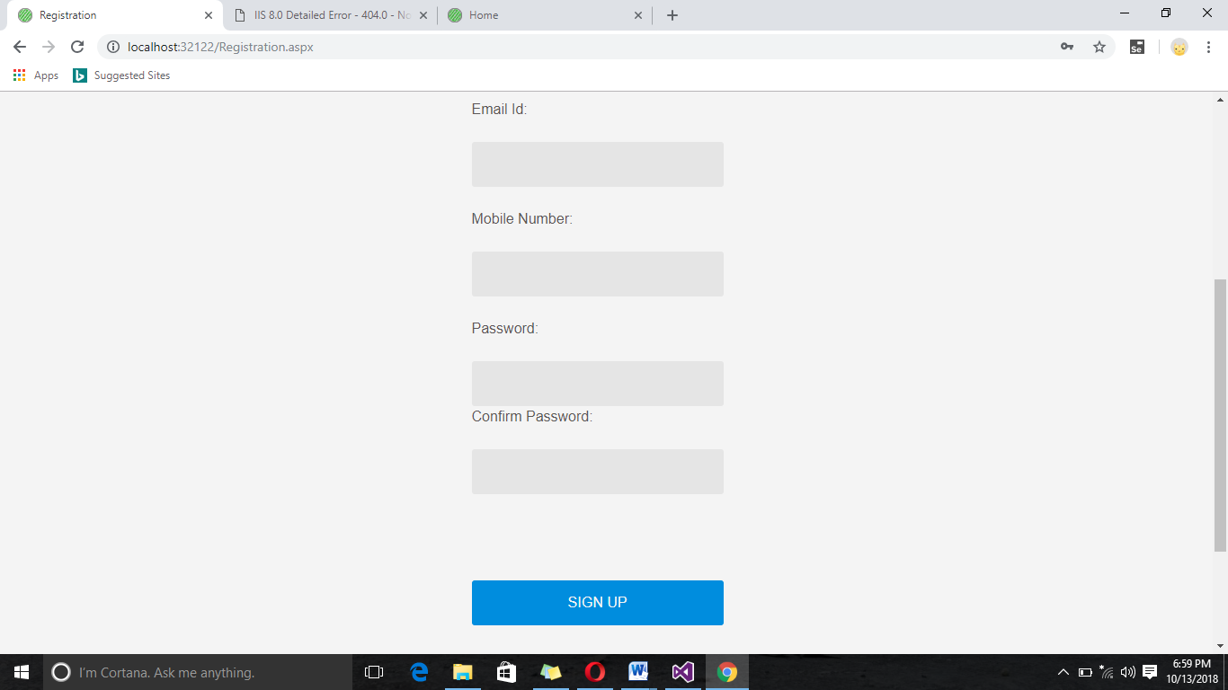

1. Home2:
2. <%@ Page Title="" Language="C#" MasterPageFile="~/MasterPage2.master" AutoEventWireup="true" CodeFile="Home2.aspx.cs" Inherits="Home2" %>  
     
     
     
   <asp:Content ID="Content1" ContentPlaceHolderID="title" runat="Server">  
       Home  
   </asp:Content>  
   <asp:Content ID="Content2" ContentPlaceHolderID="head" runat="Server">  
       <%-- ------ CSS ------ --%>  
       <link href="css/bootstrap.min.css" rel="stylesheet" type="text/css" />  
       <link href="css/font-awesome.min.css" rel="stylesheet" type="text/css" />  
       <link href="css/animate.min.css" rel="stylesheet" type="text/css" />  
       <link href="css/prettyPhoto.css" rel="stylesheet" type="text/css" />  
       <link href="css/main.css" rel="stylesheet" type="text/css" />  
       <link href="css/responsive.css" rel="stylesheet" type="text/css" />  
       <link href="http://maxcdn.bootstrapcdn.com/font-awesome/4.2.0/css/font-awesome.min.css"  
           rel="stylesheet" type="text/css" />  
     
     
     
       <!--<if lt IE 9>>  
       <script src="js/html5shiv.js"></script>  
       <script src="js/respond.min.js"></script>  
       <!<endif>-->  
       <script src="js/jquery.js" type="text/javascript"></script>  
       <script src="js/bootstrap.min.js" type="text/javascript"></script>  
       <script src="js/jquery.prettyPhoto.js" type="text/javascript"></script>  
       <script src="js/jquery.isotope.min.js" type="text/javascript"></script>  
       <script src="js/main.js" type="text/javascript"></script>  
       <script src="js/wow.min.js" type="text/javascript"></script>  
       <style type="text/css">  
       .aboutSection  
       {  
           background-color:Silver;  
       }  
       .img  
       {  
           height:100px;  
           width:100px;  
           right:400px;  
       }  
       #p1  
       {  
           height:70px;  
       }  
           .style1  
           {  
               left: 0px;  
               top: 0px;  
           }  
       </style>  
     
   </asp:Content>  
   <asp:Content ID="Content3" ContentPlaceHolderID="body" Runat="Server">  
     
     
     
     <section id="main-slider" class="no-margin">  
           <div class="carousel slide" data-ride="carousel">  
               <ol class="carousel-indicators">  
                   <li data-target="#main-slider" data-slide-to="0" class="active"></li>  
                   <li data-target="#main-slider" data-slide-to="1"></li>  
                   <li data-target="#main-slider" data-slide-to="2"></li>  
                   <li data-target="#main-slider" data-slide-to="3"></li>  
                   <li data-target="#main-slider" data-slide-to="4"></li>  
                   <li data-target="#main-slider" data-slide-to="5"></li>  
               </ol>  
               <div class="carousel-inner">  
     
                   <div class="item active" style="background-image: url(images/slider/bg1.jpg)">  
                       <div class="container">  
                           <div class="row slide-margin">  
                               <div class="col-sm-6">  
                                   <div class="carousel-content">  
                                       <h1 class="animation animated-item-1">What is C Programming?</h1>  
                                       <h2 class="animation animated-item-2">C was originally developed by Dennis Ritchie between 1969 and 1973 at Bell Labs,and used to re-implement the Unix operating system.It has since become one of the most widely used programming languages of all time.Unix was one of the first operating system kernels implemented in a language other than assembly.</h2>  
                                       <a class="btn-slide animation animated-item-3" href="InfoC.aspx">Read More</a>  
                                   </div>  
                               </div>  
     
                               <div class="col-sm-6 hidden-xs animation animated-item-4">  
                                   <div class="slider-img">  
                                       <img src="images/slider/C.png" class="img-responsive">  
                                   </div>  
                               </div>  
     
                           </div>  
                       </div>  
                   </div><!--/.item-->  
     
                   <div class="item" style="background-image: url(images/slider/bg2.jpg)">  
                       <div class="container">  
                           <div class="row slide-margin">  
                               <div class="col-sm-6">  
                                   <div class="carousel-content">  
                                       <h1 class="animation animated-item-1">What is C++?</h1>  
                                       <h2 class="animation animated-item-2">C++ is a general-purpose programming language. It has imperative, object-oriented and generic programming features, while also providing facilities for low-level memory manipulation.</h2>  
                                       <a class="btn-slide animation animated-item-3" href="InfoC++.aspx">Read More</a>  
                                   </div>  
                               </div>  
     
                               <div class="col-sm-6 hidden-xs animation animated-item-4">  
                                   <div class="slider-img">  
                                       <img src="images/slider/Cpp.png" class="img-responsive">  
                                   </div>  
                               </div>  
     
                           </div>  
                       </div>  
                   </div><!--/.item-->  
     
                   <div class="item" style="background-image: url(images/slider/bg3.jpg)">  
                       <div class="container">  
                           <div class="row slide-margin">  
                               <div class="col-sm-6">  
                                   <div class="carousel-content">  
                                       <h1 class="animation animated-item-1">What is Java?</h1>  
                                       <h2 class="animation animated-item-2">Java is a general-purpose computer programming language that is concurrent, class-based, object-oriented, and specifically designed to have as few implementation dependencies as possible. It is intended to let application developers "write once, run anywhere" (WORA)</h2>  
                                       <a class="btn-slide animation animated-item-3" href="InfoJava.aspx">Read More</a>  
                                   </div>  
                               </div>  
                               <div class="col-sm-6 hidden-xs animation animated-item-4">  
                                   <div class="slider-img">  
                                       <img src="images/slider/java.png" class="img-responsive">  
                                   </div>  
                               </div>  
                           </div>  
                       </div>  
                   </div><!--/.item-->  
     
     
                     
                   <div class="item" style="background-image: url(images/slider/sbgimg4.jpg)">  
                       <div class="container">  
                           <div class="row slide-margin">  
                               <div class="col-sm-6">  
                                   <div class="carousel-content">  
                                       <h1 class="animation animated-item-1">What is JavaScript?</h1>  
                                       <h2 class="animation animated-item-2">JavaScript is a high-level, dynamic, untyped, and interpreted programming language.It has been standardized in the ECMAScript language specification.Alongside HTML and CSS, JavaScript is one of the three core technologies of World Wide Web content production, the majority of websites employ it.</h2>  
                                       <a class="btn-slide animation animated-item-3" href="InfoJavaScript.aspx">Read More</a>  
                                   </div>  
                               </div>  
     
                               <div class="col-sm-6 hidden-xs animation animated-item-4">  
                                   <div class="slider-img">  
                                       <img src="images/slider/Javascript.png" class="img-responsive">  
                                   </div>  
                               </div>  
     
                           </div>  
                       </div>  
                   </div><!--/.item-->  
     
     
     
                     
                   <div class="item" style="background-image: url(images/slider/sbgimg5.jpg)">  
                       <div class="container">  
                           <div class="row slide-margin">  
                               <div class="col-sm-6">  
                                   <div class="carousel-content">  
                                       <h1 class="animation animated-item-1">What is C#?</h1>  
                                       <h2 class="animation animated-item-2">C# is a simple, modern, general-purpose, object-oriented programming language developed by Microsoft within its .NET initiative led by Anders Hejlsberg. This tutorial will teach you basic C# programming and will also take you through various advanced concepts related to C# programming language.</h2>  
                                       <a class="btn-slide animation animated-item-3" href="InfoCSharp.aspx">Read More</a>  
                                   </div>  
                               </div>  
     
                               <div class="col-sm-6 hidden-xs animation animated-item-4">  
                                   <div class="slider-img">  
                                       <img src="images/slider/CSharp.png" class="img-responsive">  
                                   </div>  
                               </div>  
     
                           </div>  
                       </div>  
                   </div><!--/.item-->  
     
     
     
                     
                   <div class="item" style="background-image: url(images/slider/sbgimg6.jpg)">  
                       <div class="container">  
                           <div class="row slide-margin">  
                               <div class="col-sm-6">  
                                   <div class="carousel-content">  
                                       <h1 class="animation animated-item-1">What is MySql?</h1>  
                                       <h2 class="animation animated-item-2">MySQL is the most popular Open Source Relational SQL database management system. MySQL is one of the best RDBMS being used for developing web-based software applications.</h2>  
                                       <a class="btn-slide animation animated-item-3" href="InfoMySql.aspx">Read More</a>  
                                   </div>  
                               </div>  
     
                               <div class="col-sm-6 hidden-xs animation animated-item-4">  
                                   <div class="slider-img">  
                                       <img src="images/slider/MySQL.png" class="img-responsive">  
                                   </div>  
                               </div>  
     
                           </div>  
                       </div>  
                   </div><!--/.item-->  
               </div><!--/.carousel-inner-->  
           </div><!--/.carousel-->  
           <a class="prev hidden-xs" href="#main-slider" data-slide="prev">  
               <i class="fa fa-chevron-left"></i>  
           </a>  
           <a class="next hidden-xs" href="#main-slider" data-slide="next">  
               <i class="fa fa-chevron-right"></i>  
           </a>  
       </section>  
       <!--/#main-slider-->  
       <!--Subjects-->  
       <div class="container">  
           <div class="row">  
               <div class="col-lg-12">  
                   <h2>  
                       What should you know before giving Practice and Exam?</h2>  
               </div>  
           </div>  
           <div class="row">  
               <div class="col-lg-4 col-md-3 col-sm-6">  
                   <a href="SyllabusC.aspx" class="thumbnail">  
                       <p>  
                           C Programming</p>  
                       <img src="images/slider/C.png" />  
                   </a>  
               </div>  
               <div class="col-lg-4 col-md-3 col-sm-6">  
                   <a href="SyllabusC++.aspx" class="thumbnail">  
                       <p>  
                           C++</p>  
                       <img src="images/Cpp.png" />  
                   </a>  
               </div>  
               <div class="col-lg-4 col-md-3 col-sm-6">  
                   <a href="SyllabusJava.aspx" class="thumbnail">  
                       <p>  
                           Java</p>  
                       <img src="images/java.png" />  
                   </a>  
               </div>  
           </div>  
           <div class="row">  
               <div class="col-lg-4 col-md-4 col-sm-6">  
                   <a href="Syllabus JavaScript.aspx" class="thumbnail">  
                       <p>  
                           JavaScript</p>  
                       <img src="images/slider/Javascript.png" />  
                   </a>  
               </div>  
               <div class="col-lg-4 col-md-4 col-sm-6">  
                   <a href="SyllabusMySql.aspx" class="thumbnail">  
                       <p>  
                           MySql</p>  
                       <img src="images/MySQL.png" />  
                   </a>  
               </div>  
               <div class="col-lg-4 col-md-4 col-sm-6">  
                   <a href="SyllabusCSharp.aspx" class="thumbnail">  
                       <p>  
                           C#</p>  
                       <img src="images/CSharp.png" />  
                   </a>  
               </div>  
           </div>  
       </div>  
       </div>  
       <!--Programmin langugge used-->  
       <section id="middle">  
           <div class="container">  
               <div class="row">  
                   <div class="col-sm-12 wow fadeInDown">  
                       <div class="skill">  
                           <h2>Use of Programming and Scripting languages in present Time(2016-17)</h2>  
                             
                           <div class="progress-wrap">  
                               <h3>SQL</h3>  
                               <div class="progress">  
                                 <div class="progress-bar  color1" role="progressbar" aria-valuenow="40" aria-valuemin="0" aria-valuemax="100" style="width: 90%">  
                                   <span class="bar-width">90%</span>  
                                 </div>  
     
                               </div>  
                           </div>  
     
                           <div class="progress-wrap">  
                               <h3>JAVA</h3>  
                               <div class="progress">  
                                 <div class="progress-bar color2" role="progressbar" aria-valuenow="20" aria-valuemin="0" aria-valuemax="100" style="width: 84%">  
                                  <span class="bar-width">84%</span>  
                                 </div>  
                               </div>  
                           </div>  
     
                           <div class="progress-wrap">  
                               <h3>JavaScript</h3>  
                               <div class="progress">  
                                 <div class="progress-bar color3" role="progressbar" aria-valuenow="60" aria-valuemin="0" aria-valuemax="100" style="width: 80%">  
                                   <span class="bar-width">80%</span>  
                                 </div>  
                               </div>  
                           </div>  
     
                           <div class="progress-wrap">  
                               <h3>C#</h3>  
                               <div class="progress">  
                                 <div class="progress-bar color4" role="progressbar" aria-valuenow="80" aria-valuemin="0" aria-valuemax="100" style="width: 58%">  
                                   <span class="bar-width">58%</span>  
                                 </div>  
                               </div>  
                           </div>  
     
                           <div class="progress-wrap">  
                               <h3>Python</h3>  
                               <div class="progress">  
                                 <div class="progress-bar color2" role="progressbar" aria-valuenow="20" aria-valuemin="0" aria-valuemax="100" style="width: 45%">  
                                  <span class="bar-width">45%</span>  
                                 </div>  
                               </div>  
                           <div class="progress-wrap">  
     
                             
                           <div class="C++">  
                               <h3>JAVA</h3>  
                               <div class="progress">  
                                 <div class="progress-bar color2" role="progressbar" aria-valuenow="20" aria-valuemin="0" aria-valuemax="100" style="width: 40%">  
                                  <span class="bar-width">40%</span>  
                                 </div>  
                               </div>  
                           </div>  
     
                           <div class="progress-wrap">  
                               <h3>pHp</h3>  
                               <div class="progress">  
                                 <div class="progress-bar color3" role="progressbar" aria-valuenow="60" aria-valuemin="0" aria-valuemax="100" style="width: 35%">  
                                   <span class="bar-width">35%</span>  
                                 </div>  
                               </div>  
                           </div>  
     
                           <div class="progress-wrap">  
                               <h3>IOS</h3>  
                               <div class="progress">  
                                 <div class="progress-bar color4" role="progressbar" aria-valuenow="80" aria-valuemin="0" aria-valuemax="100" style="width: 28%">  
                                   <span class="bar-width">28%</span>  
                                 </div>  
                               </div>  
                           </div>  
     
                           <div class="progress-wrap">  
                               <h3>RUBY/RAILS</h3>  
                               <div class="progress">  
                                 <div class="progress-bar color2" role="progressbar" aria-valuenow="20" aria-valuemin="0" aria-valuemax="100" style="width: 10%">  
                                  <span class="bar-width">10%</span>  
                                 </div>  
                               </div>  
                           </div>  
                           </div>  
     
                       </div>  
     
                   </div><!--/.col-sm-6-->  
                   </div>  
                   </div>  
                   </div>  
                   </section>  
                    
     
                     
     
       <footer class="row back aboutSection">  
           <div class="container" id="aboutSection">  
               <div  class="col-md-3 col-sm-6 col-xs-12">  
                   <h3>About Us</h3>  
   <img src="images/my_pic.jpg" class="img-circle img" />  
                     
                       <p>Myself Vishal V. Upadhyay</p>  
                   <p>Currently I'm Studend and hosting ProgrmmingSkills.com website</p>  
                     
                       <p>My Blogspot:</p>  
                       <p><a href="www.vishalprogrammingskills.blogspot.in">Programming Skills</a></p>  
                     
                       <p>My Youtube Channel:</p>  
                       <a href="#">Programming Skills</a>  
                     
                 
               </div>  
               <div  class="col-md-3 col-sm-6 col-xs-12">  
                   <h3>Our Vision</h3>  
                     
   <img src="images/vision.jpg"  class="img-circle img" />  
                   <div class="one_tweet">  
                       <p>To provide you a platform where you can enhance your programmming skills</p>  
                         
                   </div>  
                   <div class="one_tweet">  
                       <p>To make you comfortable with languages by knowing their different kinds of Questions</p>  
                   </div>  
                         
                   <div class="one_tweet">  
                       <p>To Certifed you in your knlowledged programming language</p>  
                   </div>  
               </div>  
                 
               <div  class="col-md-3 col-sm-6 col-xs-12">  
                   <h3>Contact us</h3>  
                     
   <img src="images/contactus.jpg"  class="img-circle img" />  
                   <p>  uvvishalupadhyay@gmail.com</p>  
                   <p>  www.vishalprogrammingskills.blogspot.in</p>  
                   <p>91-8999999911</p>  
             
               </div>  
               <div  class="col-md-3 col-sm-6 col-xs-12">  
                   <h3>Comming Soon</h3>  
                     
   <img src="images/coming soon.jpg"  class="img-circle img" />  
                   <div class="one_tweet">  
                   <p>We're comming with more languages like pHp,RUBY,Python</p>  
                   </div>  
                     
                   <div class="one_tweet">  
                       <p>We always keep update the questons so you can get more Idea about questoins</p>  
                   </div>  
                   <div class="one_tweet">  
                       <p>  
                   <a href="Feedback.aspx">Feedback</a></p>  
                   </div>  
                     
               </div>  
                 
           </div></footer>  
   </asp:Content>

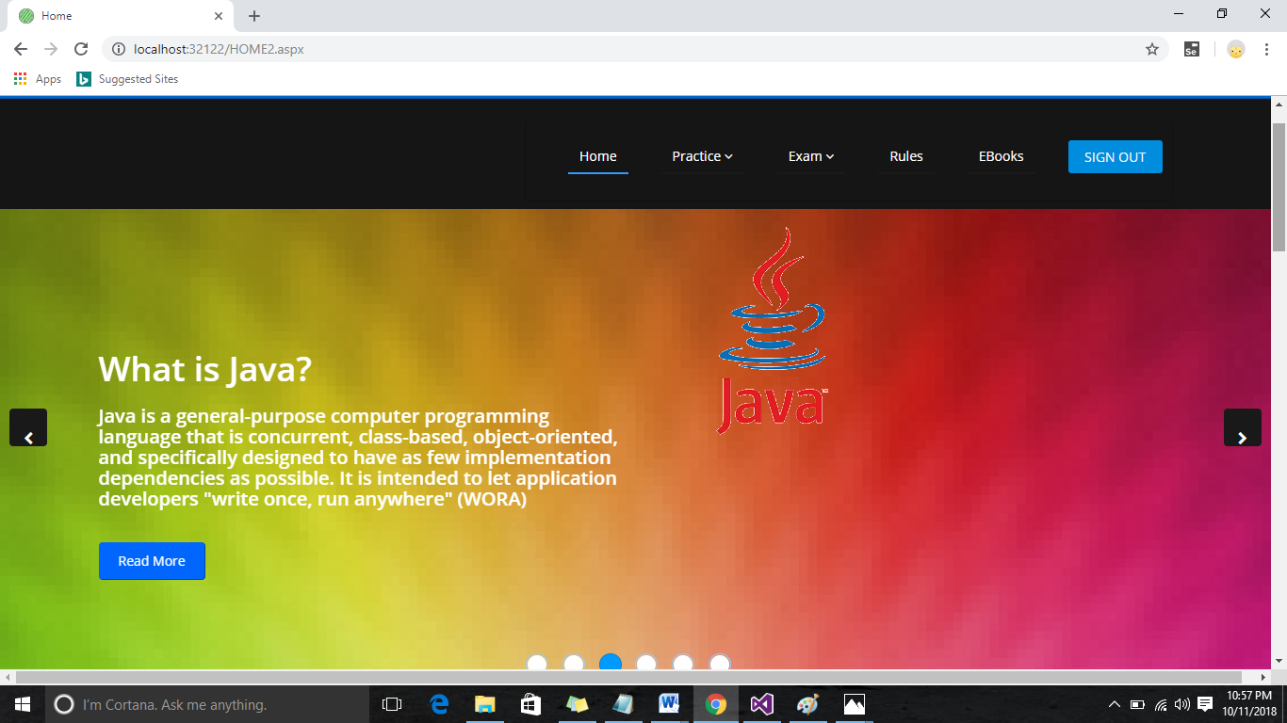

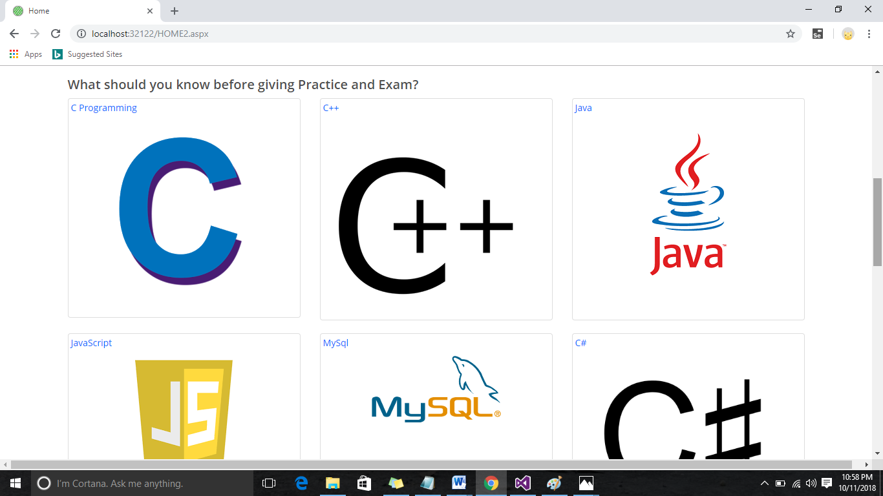

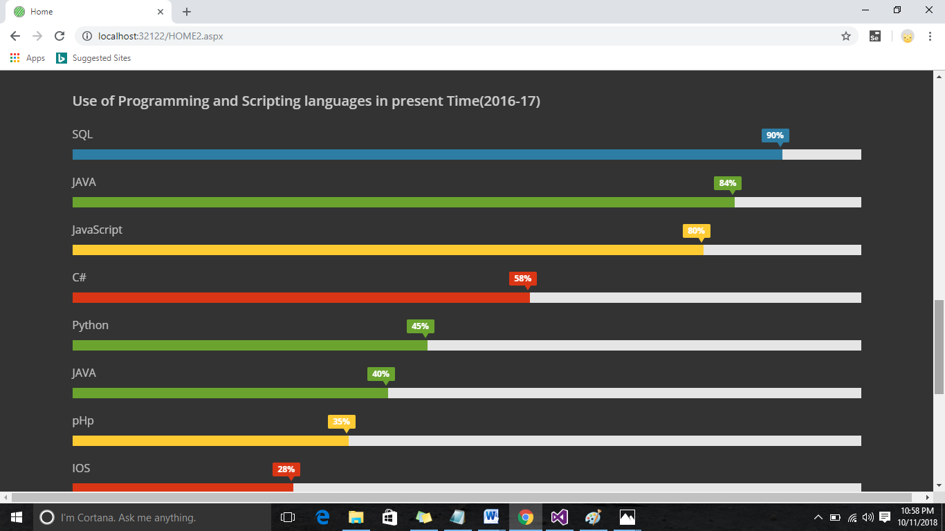

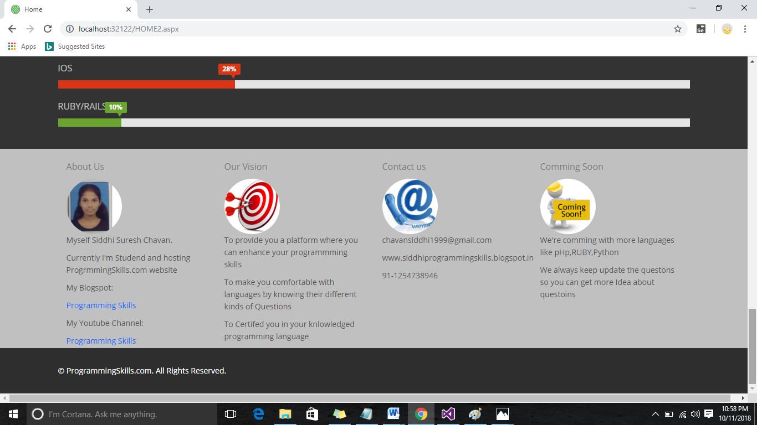

1. Practice page:

<%@ Page Language="C#" AutoEventWireup="true" CodeFile="PracticeTest.aspx.cs" Inherits="PracticeTest" %>

<!DOCTYPE html PUBLIC "-//W3C//DTD XHTML 1.0 Transitional//EN" "http://www.w3.org/TR/xhtml1/DTD/xhtml1-transitional.dtd">

<html xmlns="http://www.w3.org/1999/xhtml">

<head id="Head1" runat="server">

<title></title>

<style type="text/css">

.practice

{

float:left;

border: solid 1px;

margin:10px;

}

#ques

{

width:720px;

height:300px;

}

#ans

{

width:400px;

height:300px;

}

</style>

</head>

<body>

<form id="form1" runat="server">

<div>

<h1> <a class="navbar-brand" href="HOME2.aspx">ProgrammingSkills.com </a>

<asp:Label ID="Label2" runat="server" Text="Label"></asp:Label>

</h1>

</div>

<div>

<asp:Button ID="Button1" runat="server" Text="1" onclick="Button1_Click" class="btn btn-default btn-circle btn-sm active"

BackColor="#2fd8f0" />

&nbsp;<asp:Button ID="Button2" runat="server" Text="2" onclick="Button2_Click" class="btn btn-default btn-circle btn-sm"

BackColor="#2fd8f0" />

&nbsp;<asp:Button ID="Button3" runat="server" Text="3" onclick="Button3_Click" class="btn btn-default btn-circle btn-sm"

BackColor="#2fd8f0" />

&nbsp;<asp:Button ID="Button4" runat="server" Text="4" onclick="Button4_Click" class="btn btn-default btn-circle btn-sm"

BackColor="#2fd8f0" />

&nbsp;<asp:Button ID="Button5" runat="server" Text="5" onclick="Button5_Click" class="btn btn-default btn-circle btn-sm"

BackColor="#2fd8f0" />

&nbsp;<asp:Button ID="Button8" runat="server" BackColor="#2fd8f0"

onclick="Button8_Click" class="btn btn-default btn-circle btn-sm" Text="6" />

&nbsp;<asp:Button ID="Button9" runat="server" BackColor="#2fd8f0" onclick="Button9_Click" class="btn btn-default btn-circle btn-sm"

Text="7" />

&nbsp;<asp:Button ID="Button10" runat="server" BackColor="#2fd8f0" onclick="Button10_Click" class="btn btn-default btn-circle btn-sm"

Text="8" />

&nbsp;<asp:Button ID="Button11" runat="server" BackColor="#2fd8f0" onclick="Button11_Click" class="btn btn-default btn-circle btn-sm"

Text="9" />

&nbsp;<asp:Button ID="Button12" runat="server" BackColor="#2fd8f0" onclick="Button12_Click" class="btn btn-default btn-circle btn-sm"

Text="10" />

&nbsp;<asp:Button ID="Button13" runat="server" BackColor="#2fd8f0" onclick="Button13_Click" class="btn btn-default btn-circle btn-sm"

Text="11" />

&nbsp;<asp:Button ID="Button14" runat="server" BackColor="#2fd8f0" onclick="Button14_Click" class="btn btn-default btn-circle btn-sm"

Text="12" />

&nbsp;<asp:Button ID="Button15" runat="server" BackColor="#2fd8f0" onclick="Button15_Click" class="btn btn-default btn-circle btn-sm"

Text="13" />

&nbsp;<asp:Button ID="Button16" runat="server" BackColor="#2fd8f0" onclick="Button16_Click" class="btn btn-default btn-circle btn-sm"

Text="14" />

&nbsp;<asp:Button ID="Button17" runat="server" BackColor="#2fd8f0" onclick="Button17_Click" class="btn btn-default btn-circle btn-sm"

Text="15" />

&nbsp;<asp:Button ID="Button18" runat="server" BackColor="#2fd8f0" onclick="Button18_Click" class="btn btn-default btn-circle btn-sm"

Text="16" />

&nbsp;<asp:Button ID="Button19" runat="server" BackColor="#2fd8f0" onclick="Button19_Click" class="btn btn-default btn-circle btn-sm"

Text="17" />

&nbsp;<asp:Button ID="Button20" runat="server" BackColor="#2fd8f0" onclick="Button20_Click" class="btn btn-default btn-circle btn-sm"

Text="18" />

&nbsp;<asp:Button ID="Button21" runat="server" BackColor="#2fd8f0" onclick="Button21_Click" class="btn btn-default btn-circle btn-sm"

Text="19" />

&nbsp;<asp:Button ID="Button22" runat="server" BackColor="#2fd8f0" onclick="Button22_Click" class="btn btn-default btn-circle btn-sm"

Text="20" />

</div>

<div class="practice" id="ques">

<br />

&nbsp;&nbsp;&nbsp;

<asp:Label ID="Label1" runat="server" Text="Click Next To Strat Practice"></asp:Label>

<br /><br />

<br /><br /><br /><br /><br />

<br /><br />

&nbsp;&nbsp;&nbsp;

<asp:Button ID="Button6" runat="server" Text="Confirm"

onclick="Button6_Click" />

&nbsp;<asp:Button ID="Button7" runat="server" Text="Next" onclick="Button7_Click"

style="height: 26px" />

</div>

<div class="practice" id ="ans">

<asp:RadioButtonList ID="RadioButtonList1" runat="server">

</asp:RadioButtonList>

</div>

</form>

</body>

</html>

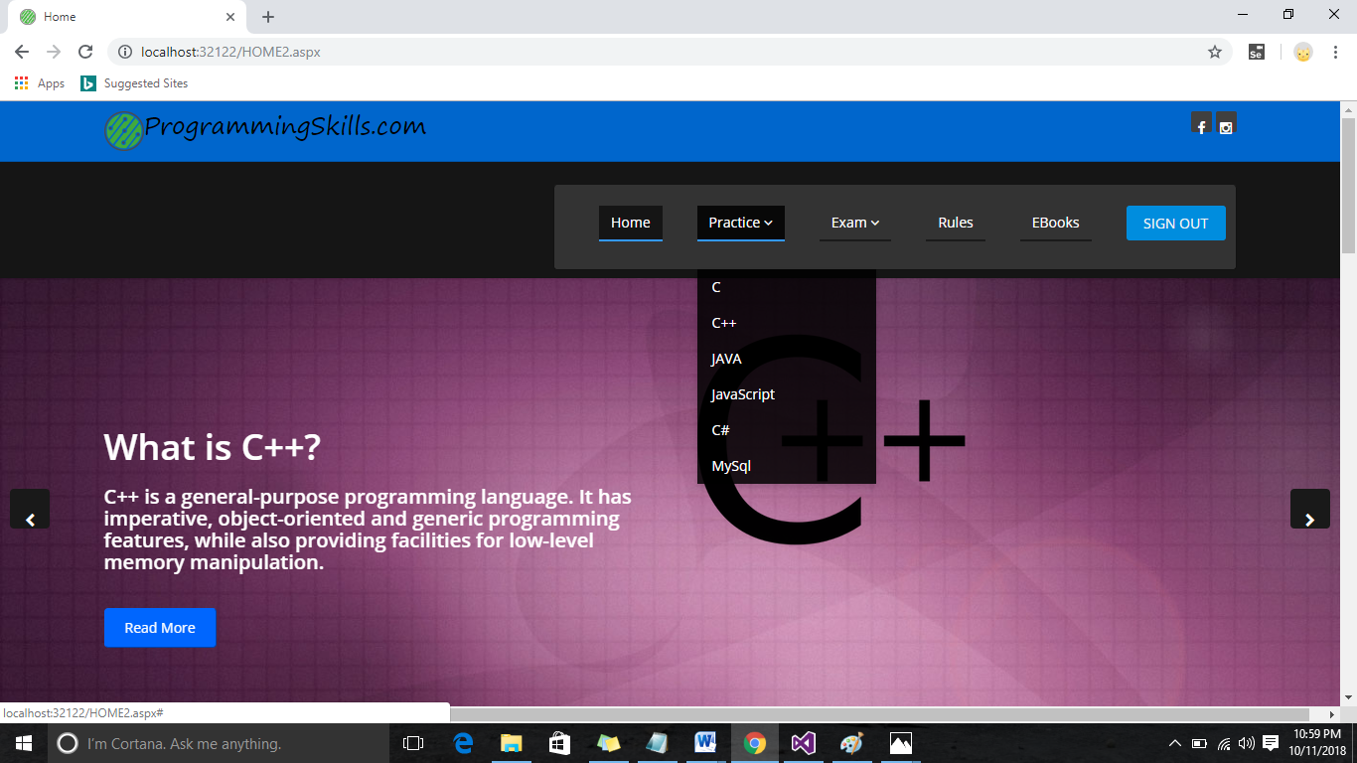

1. Page for C:

<%@ Page Title="" Language="C#" MasterPageFile="~/MasterPage2.master" AutoEventWireup="true" CodeFile="PracC.aspx.cs" Inherits="PracC" %>

<asp:Content ID="Content1" ContentPlaceHolderID="title" Runat="Server">C Practice

</asp:Content>

<asp:Content ID="Content2" ContentPlaceHolderID="head" Runat="Server">

</asp:Content>

<asp:Content ID="Content3" ContentPlaceHolderID="body" Runat="Server">

<div class="container">

<br />

<h2>Please take a look on below points before starting Practice: </h2>

<br /><hr /><br />

<ul>

<li>Make sure that you have read all the <a href="Rules.aspx">Rules</a>. </li><br />

<li>Before Starting Practice you should see our Syllabus</li> <br />

<li>There is no negative marking</li><br />

<li>All questions are Compulsary</li><br />

</ul>

<br /><br />

<asp:Button ID="Practice" runat="server" Text="Practice"

onclick="Practice_Click" />

</div>

</asp:Content>

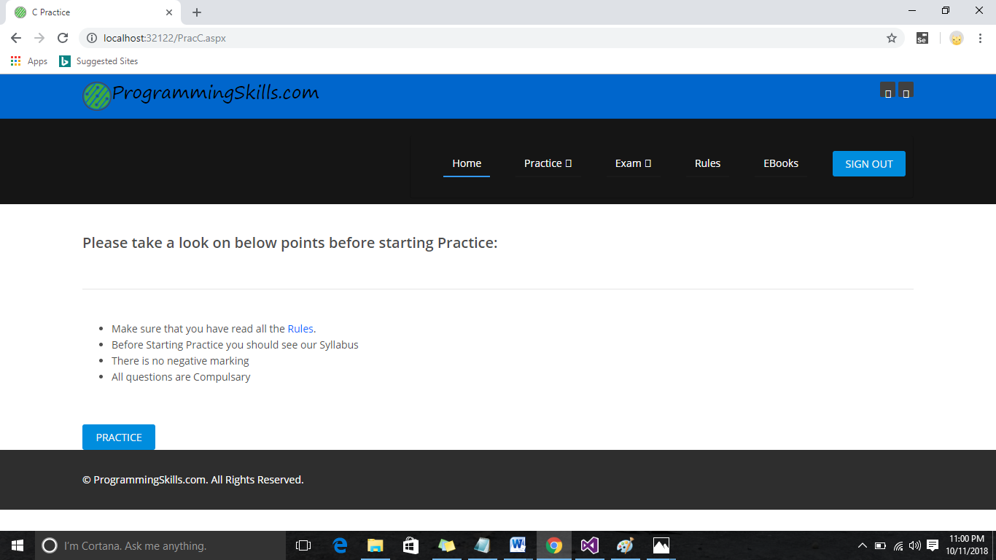

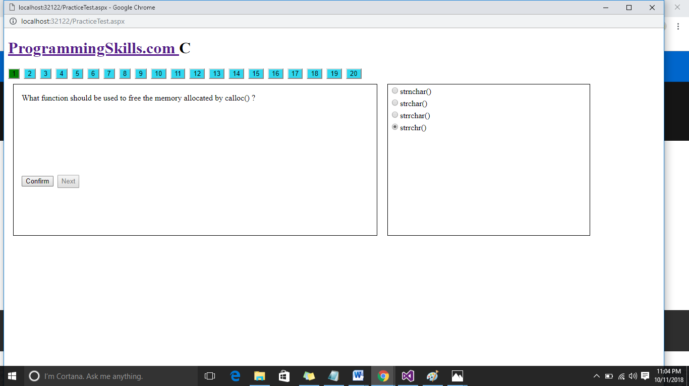

<%@ Page Language="C#" AutoEventWireup="true" CodeFile="Result.aspx.cs" Inherits="Result" %>

<!DOCTYPE html PUBLIC "-//W3C//DTD XHTML 1.0 Transitional//EN" "http://www.w3.org/TR/xhtml1/DTD/xhtml1-transitional.dtd">

<html xmlns="http://www.w3.org/1999/xhtml">

<head runat="server">

<title></title>

</head>

<body>

<form id="form1" runat="server">

<div>

<h4>

<asp:Label ID="Label2" runat="server" Text="Label"></asp:Label>

</h4>

<h4>&nbsp;</h4>

<h4>You Have given

<asp:Label ID="Label1" runat="server" Text="Label"></asp:Label> right answers!!!!!</h4>

<p>&nbsp;</p>

<p>&nbsp;</p>

<p>

<asp:Button ID="Button1" runat="server" onclick="Button1_Click"

Text="View Test Result" />

&nbsp;<asp:Button ID="Button2" runat="server" onclick="Button2_Click"

Text="Certificate" />

</p>

<br /><br />

<asp:Label ID="Label3" runat="server"></asp:Label>

</div>

</form>

</body>

</html>

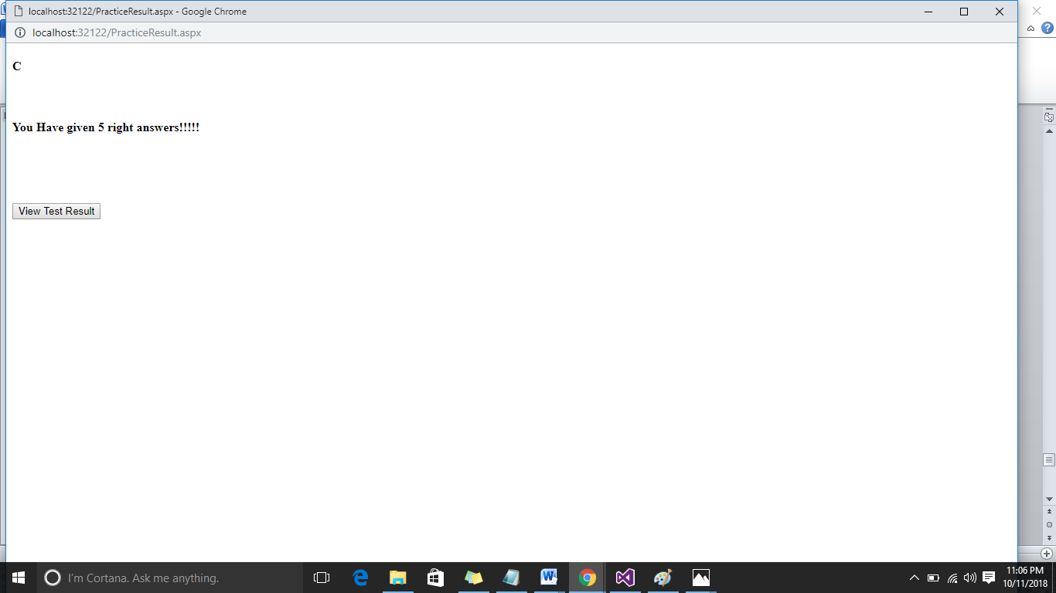

<%@ Page Language="C#" AutoEventWireup="true" CodeFile="ViewResult.aspx.cs" Inherits="ViewResult" %>

<!DOCTYPE html PUBLIC "-//W3C//DTD XHTML 1.0 Transitional//EN" "http://www.w3.org/TR/xhtml1/DTD/xhtml1-transitional.dtd">

<html xmlns="http://www.w3.org/1999/xhtml">

<head id="Head1" runat="server">

<title></title>

<%--</head>

<body>

<form id="form1" runat="server">

<asp:Label ID="Label61" runat="server" Text="Label"></asp:Label>

<br />

<br />

<br />

&nbsp;Question 1 :

<asp:Label ID="Label1" runat="server" Text="Label"></asp:Label>

<br />

Option Selected :

<asp:Label ID="Label2" runat="server" Text="Label"></asp:Label>

&nbsp;<br />

Right Answer :&nbsp;

<asp:Label ID="Label3" runat="server" Text="Label" BackColor="#33CC33"></asp:Label>

<br />

<br />

Question 2 :

<asp:Label ID="Label4" runat="server" Text="Label"></asp:Label>

<br />

Option Selected :

<asp:Label ID="Label5" runat="server" Text="Label"></asp:Label>

&nbsp;<br />

Right Answer :

<asp:Label ID="Label6" runat="server" Text="Label" BackColor="#33CC33"></asp:Label>

<br />

<br />

Question 3 :

<asp:Label ID="Label7" runat="server" Text="Label"></asp:Label>

<br />

Option Selected :

<asp:Label ID="Label8" runat="server" Text="Label"></asp:Label>

&nbsp;<br />

Right Answer :

<asp:Label ID="Label9" runat="server" Text="Label" BackColor="#33CC33"></asp:Label>

<br />

<br />

Question 4 :

<asp:Label ID="Label10" runat="server" Text="Label"></asp:Label>

<br />

Option Selected :

<asp:Label ID="Label11" runat="server" Text="Label"></asp:Label>

&nbsp;<br />

Right Answer :

<asp:Label ID="Label12" runat="server" Text="Label" BackColor="#33CC33"></asp:Label>

<br />

<br />

Question 5 :

<asp:Label ID="Label13" runat="server" Text="Label"></asp:Label>

<br />

Option Selected :

<asp:Label ID="Label14" runat="server" Text="Label"></asp:Label>

&nbsp;<br />

Right Answer :

<asp:Label ID="Label15" runat="server" Text="Label" BackColor="#33CC33"></asp:Label>

<br />

<br />

Question 6 :

<asp:Label ID="Label16" runat="server" Text="Label"></asp:Label>

<br />

Option Selected :

<asp:Label ID="Label17" runat="server" Text="Label"></asp:Label>

&nbsp;<br />

Right Answer :

<asp:Label ID="Label18" runat="server" Text="Label" BackColor="#33CC33"></asp:Label>

<br />

<br />

Question 7 :

<asp:Label ID="Label19" runat="server" Text="Label"></asp:Label>

<br />

Option Selected :

<asp:Label ID="Label20" runat="server" Text="Label"></asp:Label>

&nbsp;<br />

Right Answer :

<asp:Label ID="Label21" runat="server" Text="Label" BackColor="#33CC33"></asp:Label>

<br />

<br />

Question 8 :

<asp:Label ID="Label22" runat="server" Text="Label"></asp:Label>

<br />

Option Selected :

<asp:Label ID="Label23" runat="server" Text="Label"></asp:Label>

&nbsp;<br />

Right Answer :

<asp:Label ID="Label24" runat="server" Text="Label" BackColor="#33CC33"></asp:Label>

<br />

<br />

Question 9 ::<asp:Label ID="Label25" runat="server" Text="Label"></asp:Label>

<br />

Option Selected :

<asp:Label ID="Label26" runat="server" Text="Label"></asp:Label>

&nbsp;<br />

Right Answer :

<asp:Label ID="Label27" runat="server" Text="Label" BackColor="#33CC33"></asp:Label>

<br />

<br />

Question 10 :

<asp:Label ID="Label28" runat="server" Text="Label"></asp:Label>

<br />

Option Selected :

<asp:Label ID="Label29" runat="server" Text="Label"></asp:Label>

&nbsp;<br />

Right Answer :

<asp:Label ID="Label30" runat="server" Text="Label" BackColor="#33CC33"></asp:Label>

<br />

<br />

Question 11 :

<asp:Label ID="Label31" runat="server" Text="Label"></asp:Label>

<br />

Option Selected :

<asp:Label ID="Label32" runat="server" Text="Label"></asp:Label>

&nbsp;<br />

Right Answer :

<asp:Label ID="Label33" runat="server" Text="Label" BackColor="#33CC33"></asp:Label>

<br />

<br />

Question 12 :

<asp:Label ID="Label34" runat="server" Text="Label"></asp:Label>

<br />

Option Selected :

<asp:Label ID="Label35" runat="server" Text="Label"></asp:Label>

&nbsp;<br />

Right Answer :

<asp:Label ID="Label36" runat="server" Text="Label" BackColor="#33CC33"></asp:Label>

<br />

<br />

Question 13 :

<asp:Label ID="Label37" runat="server" Text="Label"></asp:Label>

<br />

Option Selected :

<asp:Label ID="Label38" runat="server" Text="Label"></asp:Label>

&nbsp;<br />

Right Answer :

<asp:Label ID="Label39" runat="server" Text="Label" BackColor="#33CC33"></asp:Label>

<br />

<br />

Question 14 :

<asp:Label ID="Label40" runat="server" Text="Label"></asp:Label>

<br />

Option Selected :

<asp:Label ID="Label41" runat="server" Text="Label"></asp:Label>

&nbsp;<br />

Right Answer :

<asp:Label ID="Label42" runat="server" Text="Label" BackColor="#33CC33"></asp:Label>

<br />

<br />

Question 15 :

<asp:Label ID="Label43" runat="server" Text="Label"></asp:Label>

<br />

Option Selected :

<asp:Label ID="Label44" runat="server" Text="Label"></asp:Label>

&nbsp;<br />

Right Answer :

<asp:Label ID="Label45" runat="server" Text="Label" BackColor="#33CC33"></asp:Label>

<br />

<br />

Question 16 :

<asp:Label ID="Label46" runat="server" Text="Label"></asp:Label>

<br />

Option Selected :

<asp:Label ID="Label47" runat="server" Text="Label"></asp:Label>

&nbsp;<br />

Right Answer :

<asp:Label ID="Label48" runat="server" Text="Label" BackColor="#33CC33"></asp:Label>

<br />

<br />

Question 17 :

<asp:Label ID="Label49" runat="server" Text="Label"></asp:Label>

<br />

Option Selected :

<asp:Label ID="Label50" runat="server" Text="Label"></asp:Label>

&nbsp;<br />

Right Answer :

<asp:Label ID="Label51" runat="server" Text="Label" BackColor="#33CC33"></asp:Label>

<br />

<br />

Question 18 :

<asp:Label ID="Label52" runat="server" Text="Label"></asp:Label>

<br />

Option Selected :

<asp:Label ID="Label53" runat="server" Text="Label"></asp:Label>

&nbsp;<br />

Right Answer :

<asp:Label ID="Label54" runat="server" Text="Label" BackColor="#33CC33"></asp:Label>

<br />

<br />

Question 19 :

<asp:Label ID="Label55" runat="server" Text="Label"></asp:Label>

<br />

Option Selected :

<asp:Label ID="Label56" runat="server" Text="Label"></asp:Label>

&nbsp;<br />

Right Answer :

<asp:Label ID="Label57" runat="server" Text="Label" BackColor="#33CC33"></asp:Label>

<br />

<br />

Question 20 :

<asp:Label ID="Label58" runat="server" Text="Label"></asp:Label>

<br />

Option Selected :

<asp:Label ID="Label59" runat="server" Text="Label"></asp:Label>

&nbsp;<br />

Right Answer :

<asp:Label ID="Label60" runat="server" Text="Label" BackColor="#33CC33"></asp:Label>

</form>

</body>

</html>

--%>

<style type="text/css">

.qb

{

border: solid 1px;

}

#Label61

{

font-family:Lucida Handwriting;

}

</style>

</head>

<body>

<form id="form1" runat="server">

<asp:Label ID="Label61" runat="server" Text="Label"></asp:Label>

<br />

<br />

<br />

<div class="qb">

&nbsp;Question 1 :

<asp:Label ID="Label1" runat="server" Text="Label" ForeColor="#0000CC"></asp:Label>

<br />

Option Selected :

<asp:Label ID="Label2" runat="server" Text="Label" ForeColor="Red"></asp:Label>

&nbsp;<br />

Right Answer :&nbsp;

<asp:Label ID="Label3" runat="server" Text="Label" ForeColor="Lime"></asp:Label>

</div>

<br />

<br />

<div class="qb">

Question 2 :

<asp:Label ID="Label4" runat="server" Text="Label" ForeColor="#0000CC"></asp:Label>

<br />

Option Selected :

<asp:Label ID="Label5" runat="server" Text="Label" ForeColor="Red"></asp:Label>

&nbsp;<br />

Right Answer :

<asp:Label ID="Label6" runat="server" Text="Label" ForeColor="Lime"></asp:Label>

</div>

<br />

<br />

<div class="qb">

Question 3 :

<asp:Label ID="Label7" runat="server" Text="Label" ForeColor="#0000CC"></asp:Label>

<br />

Option Selected :

<asp:Label ID="Label8" runat="server" Text="Label" ForeColor="Red"></asp:Label>

&nbsp;<br />

Right Answer :

<asp:Label ID="Label9" runat="server" Text="Label" ForeColor="Lime"></asp:Label>

</div>

<br />

<br />

<div class="qb">

Question 4 :

<asp:Label ID="Label10" runat="server" Text="Label" ForeColor="#0000CC"></asp:Label>

<br />

Option Selected :

<asp:Label ID="Label11" runat="server" Text="Label" ForeColor="Red"></asp:Label>

&nbsp;<br />

Right Answer :

<asp:Label ID="Label12" runat="server" Text="Label" ForeColor="Lime"></asp:Label>

</div>

<br />

<br />

<div class="qb">

Question 5 :

<asp:Label ID="Label13" runat="server" Text="Label" ForeColor="#0000CC"></asp:Label>

<br />

Option Selected :

<asp:Label ID="Label14" runat="server" Text="Label" ForeColor="Red"></asp:Label>

&nbsp;<br />

Right Answer :

<asp:Label ID="Label15" runat="server" Text="Label" ForeColor="Lime"></asp:Label>

</div>

<br />

<br />

<div class="qb">

Question 6 :

<asp:Label ID="Label16" runat="server" Text="Label" ForeColor="#0000CC"></asp:Label>

<br />

Option Selected :

<asp:Label ID="Label17" runat="server" Text="Label" ForeColor="Red"></asp:Label>

&nbsp;<br />

Right Answer :

<asp:Label ID="Label18" runat="server" Text="Label" ForeColor="Lime"></asp:Label>

</div>

<br />

<br />

<div class="qb">

Question 7 :

<asp:Label ID="Label19" runat="server" Text="Label" ForeColor="#0000CC"></asp:Label>

<br />

Option Selected :

<asp:Label ID="Label20" runat="server" Text="Label" ForeColor="Red"></asp:Label>

&nbsp;<br />

Right Answer :

<asp:Label ID="Label21" runat="server" Text="Label" ForeColor="Lime"></asp:Label>

</div>

<br />

<br />

<div class="qb">

Question 8 :

<asp:Label ID="Label22" runat="server" Text="Label" ForeColor="#0000CC"></asp:Label>

<br />

Option Selected :

<asp:Label ID="Label23" runat="server" Text="Label" ForeColor="Red"></asp:Label>

&nbsp;<br />

Right Answer :

<asp:Label ID="Label24" runat="server" Text="Label" ForeColor="Lime"></asp:Label>

</div>

<br />

<br />

<div class="qb">

Question 9 ::<asp:Label ID="Label25" runat="server" Text="Label" ForeColor="#0000CC"></asp:Label>

<br />

Option Selected :

<asp:Label ID="Label26" runat="server" Text="Label" ForeColor="Red"></asp:Label>

&nbsp;<br />

Right Answer :

<asp:Label ID="Label27" runat="server" Text="Label" ForeColor="Lime"></asp:Label>

</div>

<br />

<br />

<div class="qb">

Question 10 :

<asp:Label ID="Label28" runat="server" Text="Label" ForeColor="#0000CC"></asp:Label>

<br />

Option Selected :

<asp:Label ID="Label29" runat="server" Text="Label" ForeColor="Red"></asp:Label>

&nbsp;<br />

Right Answer :

<asp:Label ID="Label30" runat="server" Text="Label" ForeColor="Lime"></asp:Label>

</div> <br />

<br />

<div class="qb">

Question 11 :

<asp:Label ID="Label31" runat="server" Text="Label" ForeColor="#0000CC"></asp:Label>

<br />

Option Selected :

<asp:Label ID="Label32" runat="server" Text="Label" ForeColor="Red"></asp:Label>

&nbsp;<br />

Right Answer :

<asp:Label ID="Label33" runat="server" Text="Label" ForeColor="Lime"></asp:Label>

</div><br />

<br />

<div class="qb">

Question 12 :

<asp:Label ID="Label34" runat="server" Text="Label" ForeColor="#0000CC"></asp:Label>

<br />

Option Selected :

<asp:Label ID="Label35" runat="server" Text="Label" ForeColor="Red"></asp:Label>

&nbsp;<br />

Right Answer :

<asp:Label ID="Label36" runat="server" Text="Label" ForeColor="Lime"></asp:Label>

</div>

<br />

<br />

<div class="qb">

Question 13 :

<asp:Label ID="Label37" runat="server" Text="Label" ForeColor="#0000CC"></asp:Label>

<br />

Option Selected :

<asp:Label ID="Label38" runat="server" Text="Label" ForeColor="Red"></asp:Label>

&nbsp;<br />

Right Answer :

<asp:Label ID="Label39" runat="server" Text="Label" ForeColor="Lime"></asp:Label>

</div> <br />

<br />

<div class="qb">

Question 14 :

<asp:Label ID="Label40" runat="server" Text="Label" ForeColor="#0000CC"></asp:Label>

<br />

Option Selected :

<asp:Label ID="Label41" runat="server" Text="Label" ForeColor="Red"></asp:Label>

&nbsp;<br />

Right Answer :

<asp:Label ID="Label42" runat="server" Text="Label" ForeColor="Lime"></asp:Label>

</div><br />

<br />

<div class="qb">

Question 15 :

<asp:Label ID="Label43" runat="server" Text="Label" ForeColor="#0000CC"></asp:Label>

<br />

Option Selected :

<asp:Label ID="Label44" runat="server" Text="Label" ForeColor="Red"></asp:Label>

&nbsp;<br />

Right Answer :

<asp:Label ID="Label45" runat="server" Text="Label" ForeColor="Lime"></asp:Label>

</div><br />

<br />

<div class="qb">

Question 16 :

<asp:Label ID="Label46" runat="server" Text="Label" ForeColor="#0000CC"></asp:Label>

<br />

Option Selected :

<asp:Label ID="Label47" runat="server" Text="Label"></asp:Label>

&nbsp;<br />

Right Answer :

<asp:Label ID="Label48" runat="server" Text="Label" ForeColor="Lime"></asp:Label>

</div>

<br />

<br />

<div class="qb">

Question 17 :

<asp:Label ID="Label49" runat="server" Text="Label" ForeColor="#0000CC"></asp:Label>

<br />

Option Selected :

<asp:Label ID="Label50" runat="server" Text="Label" ForeColor="Red"></asp:Label>

&nbsp;<br />

Right Answer :

<asp:Label ID="Label51" runat="server" Text="Label" ForeColor="Lime"></asp:Label>

</div>

<br />

<br />

<div class="qb">

Question 18 :

<asp:Label ID="Label52" runat="server" Text="Label" ForeColor="#0000CC"></asp:Label>

<br />

Option Selected :

<asp:Label ID="Label53" runat="server" Text="Label" ForeColor="Red"></asp:Label>

&nbsp;<br />

Right Answer :

<asp:Label ID="Label54" runat="server" Text="Label" ForeColor="Lime"></asp:Label>

</div> <br />

<br />

<div class="qb">

Question 19 :

<asp:Label ID="Label55" runat="server" Text="Label" ForeColor="#0000CC"></asp:Label>

<br />

Option Selected :

<asp:Label ID="Label56" runat="server" Text="Label" ForeColor="Red"></asp:Label>

&nbsp;<br />

Right Answer :

<asp:Label ID="Label57" runat="server" Text="Label" ForeColor="Lime"></asp:Label>

</div> <br />

<br />

<div class="qb">

Question 20 :

<asp:Label ID="Label58" runat="server" Text="Label" ForeColor="#0000CC"></asp:Label>

<br />

Option Selected :

<asp:Label ID="Label59" runat="server" Text="Label" ForeColor="Red"></asp:Label>

&nbsp;<br />

Right Answer :

<asp:Label ID="Label60" runat="server" Text="Label" ForeColor="Lime"></asp:Label>

</div>

</form>

</body>

</html>

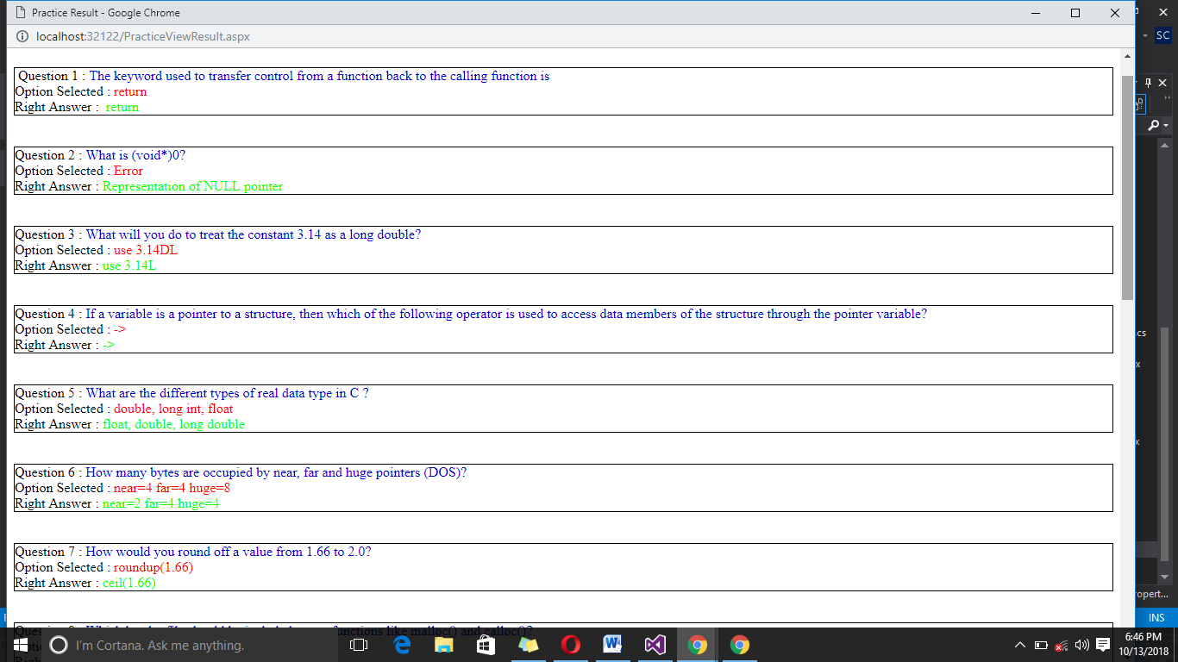

1. Exam page:

<%@ Page Language="C#" AutoEventWireup="true" CodeFile="Exam.aspx.cs" Inherits="Exam" %>

<!DOCTYPE html PUBLIC "-//W3C//DTD XHTML 1.0 Transitional//EN" "http://www.w3.org/TR/xhtml1/DTD/xhtml1-transitional.dtd"><html xmlns="http://www.w3.org/1999/xhtml"><head runat="server"><title>MySql Exam</title><style type="text/css">

#countdown1

{

border: solid 1px;

width:100px;

height:50px;

background-color:yellow;

color:red;

}

#q

{

float:left;

border: solid 1px;

margin:10px;

width:650px;

height:300px;

padding:10px;

}

#a

{

float:left;

border: solid 1px;

margin:10px;

width:400px;

height:300px;

padding:10px;

}

.practice

{

float:left;

border: solid 1px;

margin:10px;

}

#ques

{

width:720px;

height:300px;

}

#ans

{

width:400px;

height:300px;

}

</style><script type="text/javascript">

var secs = 0;

var min = 0;

var sec2 = 0;

var timerID = null;

var timerRunning = false;

var delay = 1000;

var ttclock = "0 minutes &nbsp;&nbsp;00 seconds";

function InitializeTimer(form) {

var adday3 = 20;

secs = adday3 * 60;

StopTheClock();

StartTheTimer();

}

function StopTheClock() {

if (timerRunning)

clearTimeout(timerID)

timerRunning = false;

}

function redirect() {

window.location = "http://localhost:49389/ProgrammingSkills.com/Result.aspx";

}

function StartTheTimer() {

if (secs == -1) {

StopTheClock()

document.all['BGSOUND_ID'].src = 'tower.mid';

{

redirect();

document.tower.play();

}

}

else {

min = Math.floor(secs / 60);

sec2 = secs % 60;

ttclock = min + " minutes " + "&nbsp;&nbsp;" + pad(sec2) + " seconds";

secs = secs - 1;

timerRunning = true;

timerID = self.setTimeout("StartTheTimer()", delay);

}

}

function countdown_clock(ttclock) {

html_code = '<div id="countdown"></div>';

document.write(html_code);

countdown();

}

function countdown(ttclock) {

document.all.countdown.innerHTML = ttclock;

setTimeout('countdown(ttclock);', 0);

}

function pad(n) {

if (n < 10) {

return "0" + n;

}

else {

return n;

}

}

function stripBad(string) {

for (var i = 0, output = '', valid = "eE-0123456789."; i < string.length; i++)

if (valid.indexOf(string.charAt(i)) != -1)

output += string.charAt(i)

return output;

}

window.onload = function () { InitializeTimer(form1); };

</script></head><body><form id="form1" runat="server">

<div>

<nav class="navbar navbar-inverse navbar-fixed-top">

<div class="container-fluid" id="navbar">

<div class="navbar-header">

<h1> <a class

<asp:Label ID="Label2" runat="server"></asp:Label>

</h1>&nbsp;&nbsp;&nbsp;&nbsp;&nbsp;&nbsp;&nbsp;&nbsp;&nbsp;&nbsp;&nbsp;&nbsp;&nbsp;&nbsp;&nbsp;&nbsp;&nbsp;&nbsp;&nbsp;&nbsp;&nbsp;&nbsp;&nbsp;&nbsp;&nbsp;&nbsp;&nbsp;&nbsp;&nbsp;&nbsp;

&nbsp;&nbsp;&nbsp;&nbsp;&nbsp;&nbsp;&nbsp;&nbsp;&nbsp;&nbsp;&nbsp;&nbsp;&nbsp;&nbsp;&nbsp;&nbsp;&nbsp;&nbsp;&nbsp;&nbsp;&nbsp;&nbsp;&nbsp;&nbsp;&nbsp;&nbsp;&nbsp;&nbsp;&nbsp;&nbsp;<br />

<div >

<center "background-color:#EEE8AA">

<center>

<div class="debu2" id=countdown1>

<SCRIPT type=text/javascript> countdown_clock();</SCRIPT>

</div>

</center>

<BR>

<%--<TABLE><TBODY>

<TR><TD><INPUT class="b2t" onclick=InitializeTimer(form) type=button value="Start the Timer"></TD>

<TD><INPUT class="b3t" onclick="history.go(0)" type=button value=" Stop ">

</TD></TR>

</TBODY></TABLE>--%>

</cenetr>

</div>

</div>

</div>

</nav>&nbsp;&nbsp;&nbsp;&nbsp;&nbsp;&nbsp;&nbsp;&nbsp;&nbsp;&nbsp;&nbsp;&nbsp;&nbsp;&nbsp;&nbsp;&nbsp;

<asp:ScriptManager ID="ScriptManager1" runat="server">

</asp:ScriptManager>

<asp:UpdatePanel ID="UpdatePanel1" runat="server">

<ContentTemplate>

&nbsp;&nbsp;&nbsp;&nbsp;&nbsp;&nbsp;&nbsp;&nbsp;&nbsp;&nbsp;&nbsp;&nbsp;&nbsp;&nbsp;&nbsp;&nbsp;&nbsp;&nbsp;&nbsp;&nbsp;&nbsp;&nbsp;&nbsp;&nbsp;

<div class="container">

<div class="row">

<div class="col-md-11" >

<div class="form-group">

<asp:Button ID="Button1" runat="server" Text="1" onclick="Button1_Click" class="btn btn-default btn-circle btn-sm active"

BackColor="#2fd8f0" />

&nbsp;<asp:Button ID="Button2" runat="server" Text="2" onclick="Button2_Click" class="btn btn-default btn-circle btn-sm"

BackColor="#2fd8f0" />

&nbsp;<asp:Button ID="Button3" runat="server" Text="3" onclick="Button3_Click" class="btn btn-default btn-circle btn-sm"

BackColor="#2fd8f0" />

&nbsp;<asp:Button ID="Button4" runat="server" Text="4" onclick="Button4_Click" class="btn btn-default btn-circle btn-sm"

BackColor="#2fd8f0" />

&nbsp;<asp:Button ID="Button5" runat="server" Text="5" onclick="Button5_Click" class="btn btn-default btn-circle btn-sm"

BackColor="#2fd8f0" />

&nbsp;<asp:Button ID="Button8" runat="server" BackColor="#2fd8f0"

onclick="Button8_Click" class="btn btn-default btn-circle btn-sm" Text="6" />

&nbsp;<asp:Button ID="Button9" runat="server" BackColor="#2fd8f0" onclick="Button9_Click" class="btn btn-default btn-circle btn-sm"

Text="7" />

&nbsp;<asp:Button ID="Button10" runat="server" BackColor="#2fd8f0" onclick="Button10_Click" class="btn btn-default btn-circle btn-sm"

Text="8" />

&nbsp;<asp:Button ID="Button11" runat="server" BackColor="#2fd8f0" onclick="Button11_Click" class="btn btn-default btn-circle btn-sm"

Text="9" />

&nbsp;<asp:Button ID="Button12" runat="server" BackColor="#2fd8f0" onclick="Button12_Click" class="btn btn-default btn-circle btn-sm"

Text="10" />

&nbsp;<asp:Button ID="Button13" runat="server" BackColor="#2fd8f0" onclick="Button13_Click" class="btn btn-default btn-circle btn-sm"

Text="11" />

&nbsp;<asp:Button ID="Button14" runat="server" BackColor="#2fd8f0" onclick="Button14_Click" class="btn btn-default btn-circle btn-sm"

Text="12" />

&nbsp;<asp:Button ID="Button15" runat="server" BackColor="#2fd8f0" onclick="Button15_Click" class="btn btn-default btn-circle btn-sm"

Text="13" />

&nbsp;<asp:Button ID="Button16" runat="server" BackColor="#2fd8f0" onclick="Button16_Click" class="btn btn-default btn-circle btn-sm"

Text="14" />

&nbsp;<asp:Button ID="Button17" runat="server" BackColor="#2fd8f0" onclick="Button17_Click" class="btn btn-default btn-circle btn-sm"

Text="15" />

&nbsp;<asp:Button ID="Button18" runat="server" BackColor="#2fd8f0" onclick="Button18_Click" class="btn btn-default btn-circle btn-sm"

Text="16" />

&nbsp;<asp:Button ID="Button19" runat="server" BackColor="#2fd8f0" onclick="Button19_Click" class="btn btn-default btn-circle btn-sm"

Text="17" />

&nbsp;<asp:Button ID="Button20" runat="server" BackColor="#2fd8f0" onclick="Button20_Click" class="btn btn-default btn-circle btn-sm"

Text="18" />

&nbsp;<asp:Button ID="Button21" runat="server" BackColor="#2fd8f0" onclick="Button21_Click" class="btn btn-default btn-circle btn-sm"

Text="19" />

&nbsp;<asp:Button ID="Button22" runat="server" BackColor="#2fd8f0" onclick="Button22_Click" class="btn btn-default btn-circle btn-sm"

Text="20" />

</div>

</div>

</div>

<div class="row">

<div class="col-md-10">

<div class="col-md-5">

</div>

<div class="col-md-5">

</div>

</div>

</div>

<div class="row">

<div class="col-md-11">

<div class="col-md-4">

<div id="q">

<asp:Label ID="Label1" runat="server" Text="Click on Next Button to start Exam"></asp:Label>

<br /><br /><br /><br /><br /><br /><br /><br /><br />

<br />

<asp:Button ID="Button6" runat="server" Text="Confirm"

onclick="Button6_Click" />

&nbsp;<asp:Button ID="Button7" runat="server" Text="Next" onclick="Button7_Click" />

</div>

</div>

<div id="a">

<div class="col-md-8">

<asp:RadioButtonList ID="RadioButtonList1" runat="server">

</asp:RadioButtonList>

<br />

</div>

</div>

</div>

</div></ContentTemplate></asp:UpdatePanel> <br />

</div>

</div>

</form>

</body>

</html>

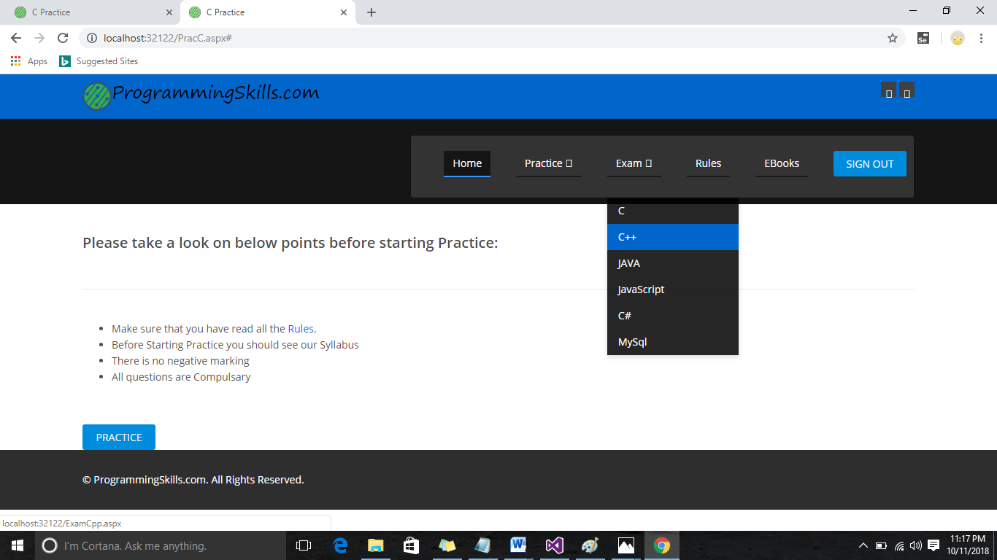

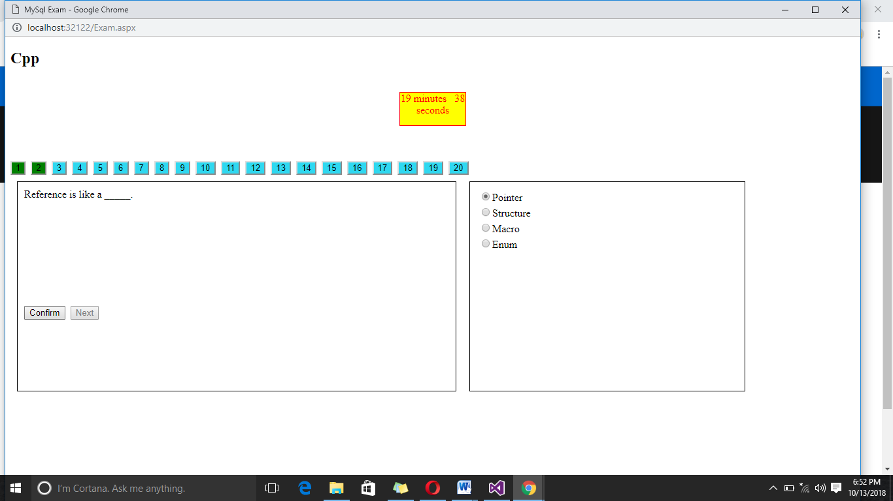

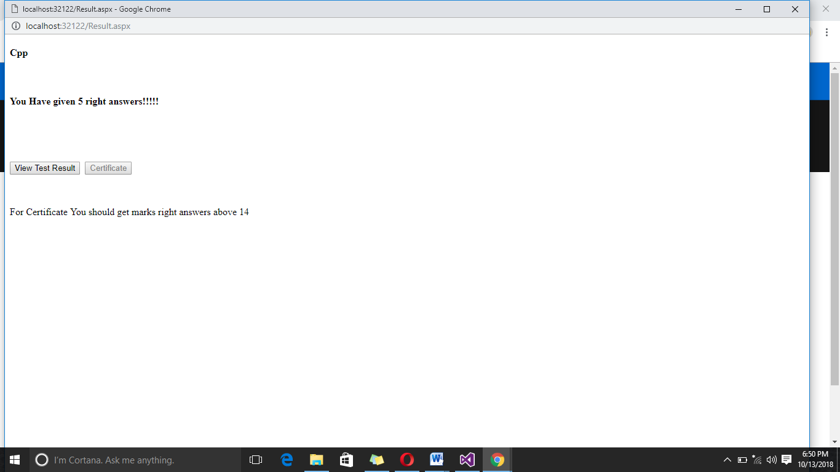

1. View Result:

<%@ Page Language="C#" AutoEventWireup="true" CodeFile="ViewResult.aspx.cs" Inherits="ViewResult" %>

<!DOCTYPE html PUBLIC "-//W3C//DTD XHTML 1.0 Transitional//EN" "http://www.w3.org/TR/xhtml1/DTD/xhtml1-transitional.dtd">

<html xmlns="http://www.w3.org/1999/xhtml">

<head id="Head1" runat="server">

<title></title>

<%--</head>

<body>

<form id="form1" runat="server">

<asp:Label ID="Label61" runat="server" Text="Label"></asp:Label>

<br />

<br />

<br />

&nbsp;Question 1 :

<asp:Label ID="Label1" runat="server" Text="Label"></asp:Label>

<br />

Option Selected :

<asp:Label ID="Label2" runat="server" Text="Label"></asp:Label>

&nbsp;<br />

Right Answer :&nbsp;

<asp:Label ID="Label3" runat="server" Text="Label" BackColor="#33CC33"></asp:Label>

<br />

<br />

Question 2 :

<asp:Label ID="Label4" runat="server" Text="Label"></asp:Label>

<br />

Option Selected :

<asp:Label ID="Label5" runat="server" Text="Label"></asp:Label>

&nbsp;<br />

Right Answer :

<asp:Label ID="Label6" runat="server" Text="Label" BackColor="#33CC33"></asp:Label>

<br />

<br />

Question 3 :

<asp:Label ID="Label7" runat="server" Text="Label"></asp:Label>

<br />

Option Selected :

<asp:Label ID="Label8" runat="server" Text="Label"></asp:Label>

&nbsp;<br />

Right Answer :

<asp:Label ID="Label9" runat="server" Text="Label" BackColor="#33CC33"></asp:Label>

<br />

<br />

Question 4 :

<asp:Label ID="Label10" runat="server" Text="Label"></asp:Label>

<br />

Option Selected :

<asp:Label ID="Label11" runat="server" Text="Label"></asp:Label>

&nbsp;<br />

Right Answer :

<asp:Label ID="Label12" runat="server" Text="Label" BackColor="#33CC33"></asp:Label>

<br />

<br />

Question 5 :

<asp:Label ID="Label13" runat="server" Text="Label"></asp:Label>

<br />

Option Selected :

<asp:Label ID="Label14" runat="server" Text="Label"></asp:Label>

&nbsp;<br />

Right Answer :

<asp:Label ID="Label15" runat="server" Text="Label" BackColor="#33CC33"></asp:Label>

<br />

<br />

Question 6 :

<asp:Label ID="Label16" runat="server" Text="Label"></asp:Label>

<br />

Option Selected :

<asp:Label ID="Label17" runat="server" Text="Label"></asp:Label>

&nbsp;<br />

Right Answer :

<asp:Label ID="Label18" runat="server" Text="Label" BackColor="#33CC33"></asp:Label>

<br />

<br />

Question 7 :

<asp:Label ID="Label19" runat="server" Text="Label"></asp:Label>

<br />

Option Selected :

<asp:Label ID="Label20" runat="server" Text="Label"></asp:Label>

&nbsp;<br />

Right Answer :

<asp:Label ID="Label21" runat="server" Text="Label" BackColor="#33CC33"></asp:Label>

<br />

<br />

Question 8 :

<asp:Label ID="Label22" runat="server" Text="Label"></asp:Label>

<br />

Option Selected :

<asp:Label ID="Label23" runat="server" Text="Label"></asp:Label>

&nbsp;<br />

Right Answer :

<asp:Label ID="Label24" runat="server" Text="Label" BackColor="#33CC33"></asp:Label>

<br />

<br />

Question 9 ::<asp:Label ID="Label25" runat="server" Text="Label"></asp:Label>

<br />

Option Selected :

<asp:Label ID="Label26" runat="server" Text="Label"></asp:Label>

&nbsp;<br />

Right Answer :

<asp:Label ID="Label27" runat="server" Text="Label" BackColor="#33CC33"></asp:Label>

<br />

<br />

Question 10 :

<asp:Label ID="Label28" runat="server" Text="Label"></asp:Label>

<br />

Option Selected :

<asp:Label ID="Label29" runat="server" Text="Label"></asp:Label>

&nbsp;<br />

Right Answer :

<asp:Label ID="Label30" runat="server" Text="Label" BackColor="#33CC33"></asp:Label>

<br />

<br />

Question 11 :

<asp:Label ID="Label31" runat="server" Text="Label"></asp:Label>

<br />

Option Selected :

<asp:Label ID="Label32" runat="server" Text="Label"></asp:Label>

&nbsp;<br />

Right Answer :

<asp:Label ID="Label33" runat="server" Text="Label" BackColor="#33CC33"></asp:Label>

<br />

<br />

Question 12 :

<asp:Label ID="Label34" runat="server" Text="Label"></asp:Label>

<br />

Option Selected :

<asp:Label ID="Label35" runat="server" Text="Label"></asp:Label>

&nbsp;<br />

Right Answer :

<asp:Label ID="Label36" runat="server" Text="Label" BackColor="#33CC33"></asp:Label>

<br />

<br />

Question 13 :

<asp:Label ID="Label37" runat="server" Text="Label"></asp:Label>

<br />

Option Selected :

<asp:Label ID="Label38" runat="server" Text="Label"></asp:Label>

&nbsp;<br />

Right Answer :

<asp:Label ID="Label39" runat="server" Text="Label" BackColor="#33CC33"></asp:Label>

<br />

<br />

Question 14 :

<asp:Label ID="Label40" runat="server" Text="Label"></asp:Label>

<br />

Option Selected :

<asp:Label ID="Label41" runat="server" Text="Label"></asp:Label>

&nbsp;<br />

Right Answer :

<asp:Label ID="Label42" runat="server" Text="Label" BackColor="#33CC33"></asp:Label>

<br />

<br />

Question 15 :

<asp:Label ID="Label43" runat="server" Text="Label"></asp:Label>

<br />

Option Selected :

<asp:Label ID="Label44" runat="server" Text="Label"></asp:Label>

&nbsp;<br />

Right Answer :

<asp:Label ID="Label45" runat="server" Text="Label" BackColor="#33CC33"></asp:Label>

<br />

<br />

Question 16 :

<asp:Label ID="Label46" runat="server" Text="Label"></asp:Label>

<br />

Option Selected :

<asp:Label ID="Label47" runat="server" Text="Label"></asp:Label>

&nbsp;<br />

Right Answer :

<asp:Label ID="Label48" runat="server" Text="Label" BackColor="#33CC33"></asp:Label>

<br />

<br />

Question 17 :

<asp:Label ID="Label49" runat="server" Text="Label"></asp:Label>

<br />

Option Selected :

<asp:Label ID="Label50" runat="server" Text="Label"></asp:Label>

&nbsp;<br />

Right Answer :

<asp:Label ID="Label51" runat="server" Text="Label" BackColor="#33CC33"></asp:Label>

<br />

<br />

Question 18 :

<asp:Label ID="Label52" runat="server" Text="Label"></asp:Label>

<br />

Option Selected :

<asp:Label ID="Label53" runat="server" Text="Label"></asp:Label>

&nbsp;<br />

Right Answer :

<asp:Label ID="Label54" runat="server" Text="Label" BackColor="#33CC33"></asp:Label>

<br />

<br />

Question 19 :

<asp:Label ID="Label55" runat="server" Text="Label"></asp:Label>

<br />

Option Selected :

<asp:Label ID="Label56" runat="server" Text="Label"></asp:Label>

&nbsp;<br />

Right Answer :

<asp:Label ID="Label57" runat="server" Text="Label" BackColor="#33CC33"></asp:Label>

<br />

<br />

Question 20 :

<asp:Label ID="Label58" runat="server" Text="Label"></asp:Label>

<br />

Option Selected :

<asp:Label ID="Label59" runat="server" Text="Label"></asp:Label>

&nbsp;<br />

Right Answer :

<asp:Label ID="Label60" runat="server" Text="Label" BackColor="#33CC33"></asp:Label>

</form>

</body>

</html>

--%>

<style type="text/css">

.qb

{

border: solid 1px;

}

#Label61

{

font-family:Lucida Handwriting;

}

</style>

</head>

<body>

<form id="form1" runat="server">

<asp:Label ID="Label61" runat="server" Text="Label"></asp:Label>

<br />

<br />

<br />

<div class="qb">

&nbsp;Question 1 :

<asp:Label ID="Label1" runat="server" Text="Label" ForeColor="#0000CC"></asp:Label>

<br />

Option Selected :

<asp:Label ID="Label2" runat="server" Text="Label" ForeColor="Red"></asp:Label>

&nbsp;<br />

Right Answer :&nbsp;

<asp:Label ID="Label3" runat="server" Text="Label" ForeColor="Lime"></asp:Label>

</div>

<br />

<br />

<div class="qb">

Question 2 :

<asp:Label ID="Label4" runat="server" Text="Label" ForeColor="#0000CC"></asp:Label>

<br />

Option Selected :

<asp:Label ID="Label5" runat="server" Text="Label" ForeColor="Red"></asp:Label>

&nbsp;<br />

Right Answer :

<asp:Label ID="Label6" runat="server" Text="Label" ForeColor="Lime"></asp:Label>

</div>

<br />

<br />

<div class="qb">

Question 3 :

<asp:Label ID="Label7" runat="server" Text="Label" ForeColor="#0000CC"></asp:Label>

<br />

Option Selected :

<asp:Label ID="Label8" runat="server" Text="Label" ForeColor="Red"></asp:Label>

&nbsp;<br />

Right Answer :

<asp:Label ID="Label9" runat="server" Text="Label" ForeColor="Lime"></asp:Label>

</div>

<br />

<br />

<div class="qb">

Question 4 :

<asp:Label ID="Label10" runat="server" Text="Label" ForeColor="#0000CC"></asp:Label>

<br />

Option Selected :

<asp:Label ID="Label11" runat="server" Text="Label" ForeColor="Red"></asp:Label>

&nbsp;<br />

Right Answer :

<asp:Label ID="Label12" runat="server" Text="Label" ForeColor="Lime"></asp:Label>

</div>

<br />

<br />

<div class="qb">

Question 5 :

<asp:Label ID="Label13" runat="server" Text="Label" ForeColor="#0000CC"></asp:Label>

<br />

Option Selected :

<asp:Label ID="Label14" runat="server" Text="Label" ForeColor="Red"></asp:Label>

&nbsp;<br />

Right Answer :

<asp:Label ID="Label15" runat="server" Text="Label" ForeColor="Lime"></asp:Label>

</div>

<br />

<br />

<div class="qb">

Question 6 :

<asp:Label ID="Label16" runat="server" Text="Label" ForeColor="#0000CC"></asp:Label>

<br />

Option Selected :

<asp:Label ID="Label17" runat="server" Text="Label" ForeColor="Red"></asp:Label>

&nbsp;<br />

Right Answer :

<asp:Label ID="Label18" runat="server" Text="Label" ForeColor="Lime"></asp:Label>

</div>

<br />

<br />

<div class="qb">

Question 7 :

<asp:Label ID="Label19" runat="server" Text="Label" ForeColor="#0000CC"></asp:Label>

<br />

Option Selected :

<asp:Label ID="Label20" runat="server" Text="Label" ForeColor="Red"></asp:Label>

&nbsp;<br />

Right Answer :

<asp:Label ID="Label21" runat="server" Text="Label" ForeColor="Lime"></asp:Label>

</div>

<br />

<br />

<div class="qb">

Question 8 :

<asp:Label ID="Label22" runat="server" Text="Label" ForeColor="#0000CC"></asp:Label>

<br />

Option Selected :

<asp:Label ID="Label23" runat="server" Text="Label" ForeColor="Red"></asp:Label>

&nbsp;<br />

Right Answer :

<asp:Label ID="Label24" runat="server" Text="Label" ForeColor="Lime"></asp:Label>

</div>

<br />

<br />

<div class="qb">

Question 9 ::<asp:Label ID="Label25" runat="server" Text="Label" ForeColor="#0000CC"></asp:Label>

<br />

Option Selected :

<asp:Label ID="Label26" runat="server" Text="Label" ForeColor="Red"></asp:Label>

&nbsp;<br />

Right Answer :

<asp:Label ID="Label27" runat="server" Text="Label" ForeColor="Lime"></asp:Label>

</div>

<br />

<br />

<div class="qb">

Question 10 :

<asp:Label ID="Label28" runat="server" Text="Label" ForeColor="#0000CC"></asp:Label>

<br />

Option Selected :

<asp:Label ID="Label29" runat="server" Text="Label" ForeColor="Red"></asp:Label>

&nbsp;<br />

Right Answer :

<asp:Label ID="Label30" runat="server" Text="Label" ForeColor="Lime"></asp:Label>

</div> <br />

<br />

<div class="qb">

Question 11 :

<asp:Label ID="Label31" runat="server" Text="Label" ForeColor="#0000CC"></asp:Label>

<br />

Option Selected :

<asp:Label ID="Label32" runat="server" Text="Label" ForeColor="Red"></asp:Label>

&nbsp;<br />

Right Answer :

<asp:Label ID="Label33" runat="server" Text="Label" ForeColor="Lime"></asp:Label>

</div><br />

<br />

<div class="qb">

Question 12 :

<asp:Label ID="Label34" runat="server" Text="Label" ForeColor="#0000CC"></asp:Label>

<br />

Option Selected :

<asp:Label ID="Label35" runat="server" Text="Label" ForeColor="Red"></asp:Label>

&nbsp;<br />

Right Answer :

<asp:Label ID="Label36" runat="server" Text="Label" ForeColor="Lime"></asp:Label>

</div>

<br />

<br />

<div class="qb">

Question 13 :

<asp:Label ID="Label37" runat="server" Text="Label" ForeColor="#0000CC"></asp:Label>

<br />

Option Selected :

<asp:Label ID="Label38" runat="server" Text="Label" ForeColor="Red"></asp:Label>

&nbsp;<br />

Right Answer :

<asp:Label ID="Label39" runat="server" Text="Label" ForeColor="Lime"></asp:Label>

</div> <br />

<br />

<div class="qb">

Question 14 :

<asp:Label ID="Label40" runat="server" Text="Label" ForeColor="#0000CC"></asp:Label>

<br />

Option Selected :

<asp:Label ID="Label41" runat="server" Text="Label" ForeColor="Red"></asp:Label>

&nbsp;<br />

Right Answer :

<asp:Label ID="Label42" runat="server" Text="Label" ForeColor="Lime"></asp:Label>

</div><br />

<br />

<div class="qb">

Question 15 :

<asp:Label ID="Label43" runat="server" Text="Label" ForeColor="#0000CC"></asp:Label>

<br />

Option Selected :

<asp:Label ID="Label44" runat="server" Text="Label" ForeColor="Red"></asp:Label>

&nbsp;<br />

Right Answer :

<asp:Label ID="Label45" runat="server" Text="Label" ForeColor="Lime"></asp:Label>

</div><br />

<br />

<div class="qb">

Question 16 :

<asp:Label ID="Label46" runat="server" Text="Label" ForeColor="#0000CC"></asp:Label>

<br />

Option Selected :

<asp:Label ID="Label47" runat="server" Text="Label"></asp:Label>

&nbsp;<br />

Right Answer :

<asp:Label ID="Label48" runat="server" Text="Label" ForeColor="Lime"></asp:Label>

</div>

<br />

<br />

<div class="qb">

Question 17 :

<asp:Label ID="Label49" runat="server" Text="Label" ForeColor="#0000CC"></asp:Label>

<br />

Option Selected :

<asp:Label ID="Label50" runat="server" Text="Label" ForeColor="Red"></asp:Label>

&nbsp;<br />

Right Answer :

<asp:Label ID="Label51" runat="server" Text="Label" ForeColor="Lime"></asp:Label>

</div>

<br />

<br />

<div class="qb">

Question 18 :

<asp:Label ID="Label52" runat="server" Text="Label" ForeColor="#0000CC"></asp:Label>

<br />

Option Selected :

<asp:Label ID="Label53" runat="server" Text="Label" ForeColor="Red"></asp:Label>

&nbsp;<br />

Right Answer :

<asp:Label ID="Label54" runat="server" Text="Label" ForeColor="Lime"></asp:Label>

</div> <br />

<br />

<div class="qb">

Question 19 :

<asp:Label ID="Label55" runat="server" Text="Label" ForeColor="#0000CC"></asp:Label>

<br />

Option Selected :

<asp:Label ID="Label56" runat="server" Text="Label" ForeColor="Red"></asp:Label>

&nbsp;<br />

Right Answer :

<asp:Label ID="Label57" runat="server" Text="Label" ForeColor="Lime"></asp:Label>

</div> <br />

<br />

<div class="qb">

Question 20 :

<asp:Label ID="Label58" runat="server" Text="Label" ForeColor="#0000CC"></asp:Label>

<br />

Option Selected :

<asp:Label ID="Label59" runat="server" Text="Label" ForeColor="Red"></asp:Label>

&nbsp;<br />

Right Answer :

<asp:Label ID="Label60" runat="server" Text="Label" ForeColor="Lime"></asp:Label>

</div>

</form>

</body>

</html>

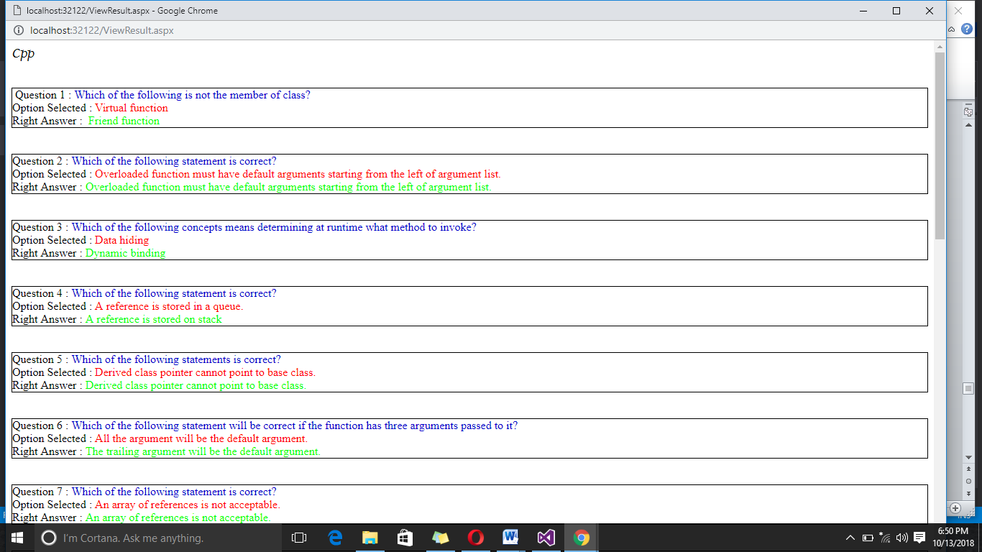

1. Certificate Page:

<%@ Page Language="C#" AutoEventWireup="true" CodeFile="Cirtificate.aspx.cs" Inherits="Cirtificate" %>

<!DOCTYPE html PUBLIC "-//W3C//DTD XHTML 1.0 Transitional//EN" "http://www.w3.org/TR/xhtml1/DTD/xhtml1-transitional.dtd">

<html xmlns="http://www.w3.org/1999/xhtml">

<head runat="server">

<title></title>

<style type="text/css">

#d2

{

border:solid 1px;

background-color:Silver;

width:1000px;

margin-left:200px;

margin-top:150px;

}

.d1

{

float:left;

padding:10px;

}

#dd

{

width: 98px;

height: 79px;

}

#d3

{

width: 851px;

height: 79px;

}

</style>

</head>

<body>

<form id="form1" runat="server">

<div id="d2">

<div>

<div class="d1" id="dd">

<asp:Image ID="Image1" runat="server" Height="83px"

ImageUrl="~/images/logo.png" Width="103px" />

</div>

<div class="d1" id="d3">

<asp:Image ID="Image2" runat="server" Height="84px"

ImageUrl="~/images/slider/bg2.jpg" Width="858px" />

</div>

&nbsp;<br />

<br />

&nbsp;</div>

<br />

<br />

<br />

<br />

<br />

<br />&nbsp;&nbsp;&nbsp;&nbsp;&nbsp;&nbsp;&nbsp;

<asp:Label ID="Label1" runat="server"></asp:Label>

<br />

<br />

<br />

&nbsp;&nbsp;&nbsp;&nbsp;&nbsp;&nbsp;&nbsp;&nbsp;&nbsp;&nbsp;&nbsp;&nbsp;&nbsp;&nbsp;&nbsp;&nbsp;&nbsp;&nbsp;&nbsp;&nbsp;&nbsp;&nbsp;&nbsp;&nbsp;&nbsp;&nbsp;&nbsp;&nbsp;&nbsp;&nbsp;&nbsp;&nbsp;&nbsp;&nbsp;&nbsp;&nbsp;&nbsp;&nbsp;&nbsp;&nbsp;

He has successfully completed the&nbsp;

<asp:Label ID="Label2" runat="server"></asp:Label> &nbsp; exam from ProgrammingSkills.com

<br />

<br />

<h3>Authorized by:<br /> <h2> Vishal V. Upadhyay</h2></h3>

<br />

<br />

<br /><br />

</div>

<br />

<asp:Button ID="Button1" runat="server" Text="Print"

OnClientClick="JavaScript:window.print();"

onclick="Button1_Click" CausesValidation="False"/>

<br /><br />

</div>

</div>

</form>

</body>

</html>

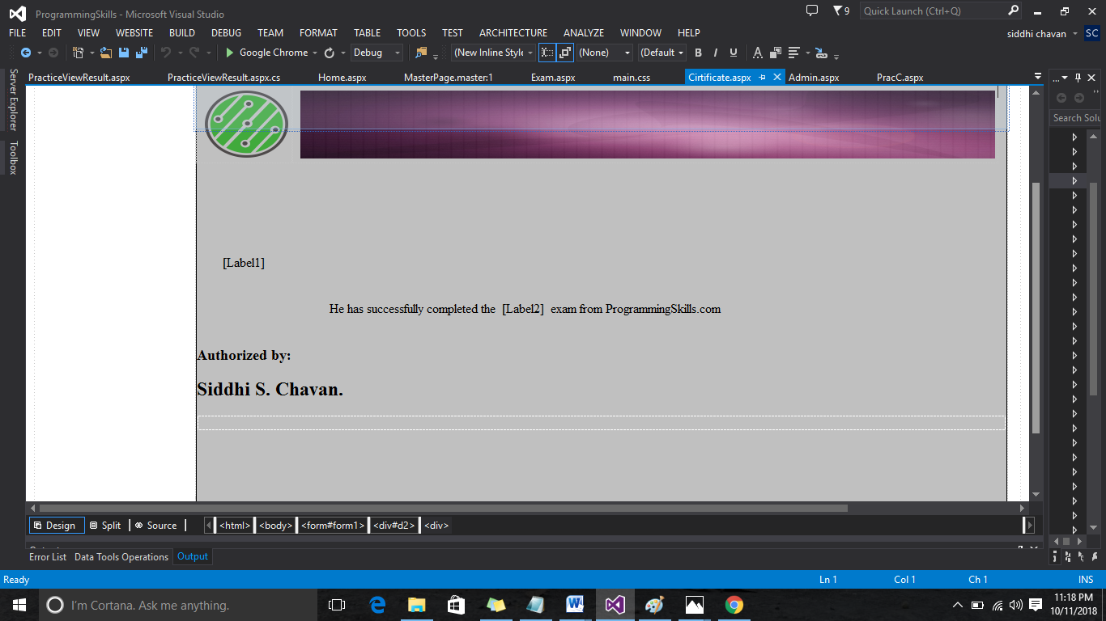

1. Rule Page:

<%@ Page Title="" Language="C#" MasterPageFile="~/MasterPage2.master" AutoEventWireup="true" CodeFile="Rules.aspx.cs" Inherits="Rules" %>

<asp:Content ID="Content1" ContentPlaceHolderID="title" Runat="Server">Rules

</asp:Content>

<asp:Content ID="Content2" ContentPlaceHolderID="head" Runat="Server">

</asp:Content>

<asp:Content ID="Content3" ContentPlaceHolderID="body" Runat="Server">

<div class="container">

<br />

<h2>Rules for Practice and Exam: </h2>

<br /><hr />

<h2>Exam:</h2>

<ul>

<li>Before Starting Exam you should see our Syllabus</li> <br />

<li>There is no negative marking</li><br />

<li>All questions are Compulsary</li><br />

<li>If you have more than 12 right answers out of 20 than only you will get certificate</li><br />

<li>There is no extra charge for certificate</li>

</ul>

<br /><br />

<h2>Practice:</h2>

<ul>

<li>Before Starting Prctice you should see our Syllabus</li> <br />

<li>There is no negative marking</li><br />

<li>All questions are Compulsary</li><br />

</ul>

<br /><br />

</div>

</asp:Content>

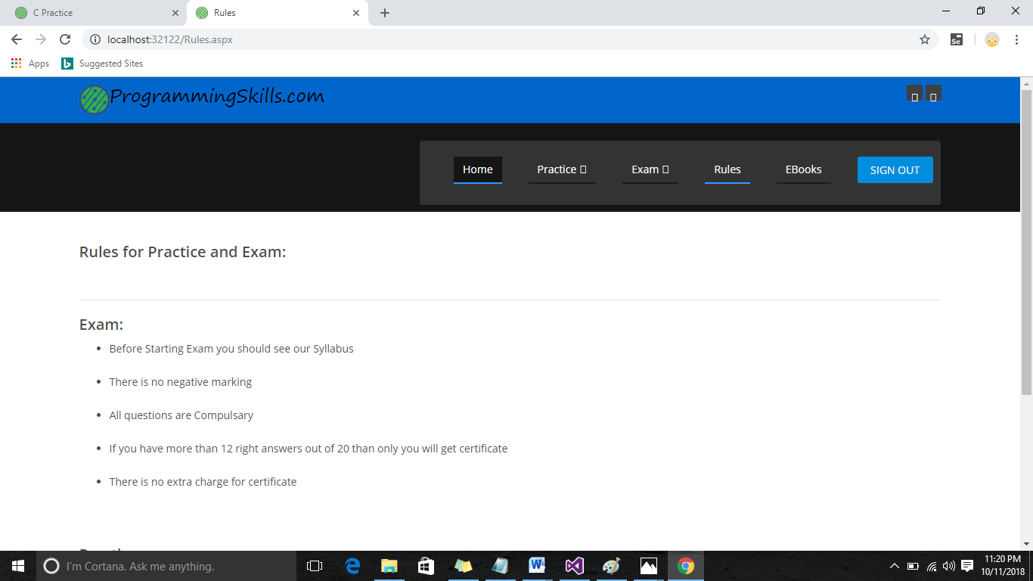

1. Admin Page:

<%@ Page Title="" Language="C#" MasterPageFile="~/MasterPage2.master" AutoEventWireup="true" CodeFile="Admin.aspx.cs" Inherits="Admin" %>

<asp:Content ID="Content1" ContentPlaceHolderID="title" Runat="Server">Admin Page

</asp:Content>

<asp:Content ID="Content2" ContentPlaceHolderID="head" Runat="Server">

<style type="text/css">

.dh

{

border: solid 1px;

width:200px;

height:200px;

float:left;

padding:30px;

margin:60px;

background-color:blueviolet;

text-align:center;

}

h2

{

color:yellow;

}

</style>

</asp:Content>

<asp:Content ID="Content3" ContentPlaceHolderID="body" Runat="Server">

<div class="dh">

<a href="AddQuestions.aspx"><h2>Add<br />Question</h2></a>

</div>

<div class="dh">

<a href="SeeUsers.aspx"> <h2>See<br />Users</h2></a> </div>

<div class="dh">

<a href="SeeFeedback.aspx"><h2>See<br />Feedback</h2></a>

</div>

<br /><br /><br /><br /><br /><br /><br /><br /><br /><br /><br /><br />

</asp:Content>

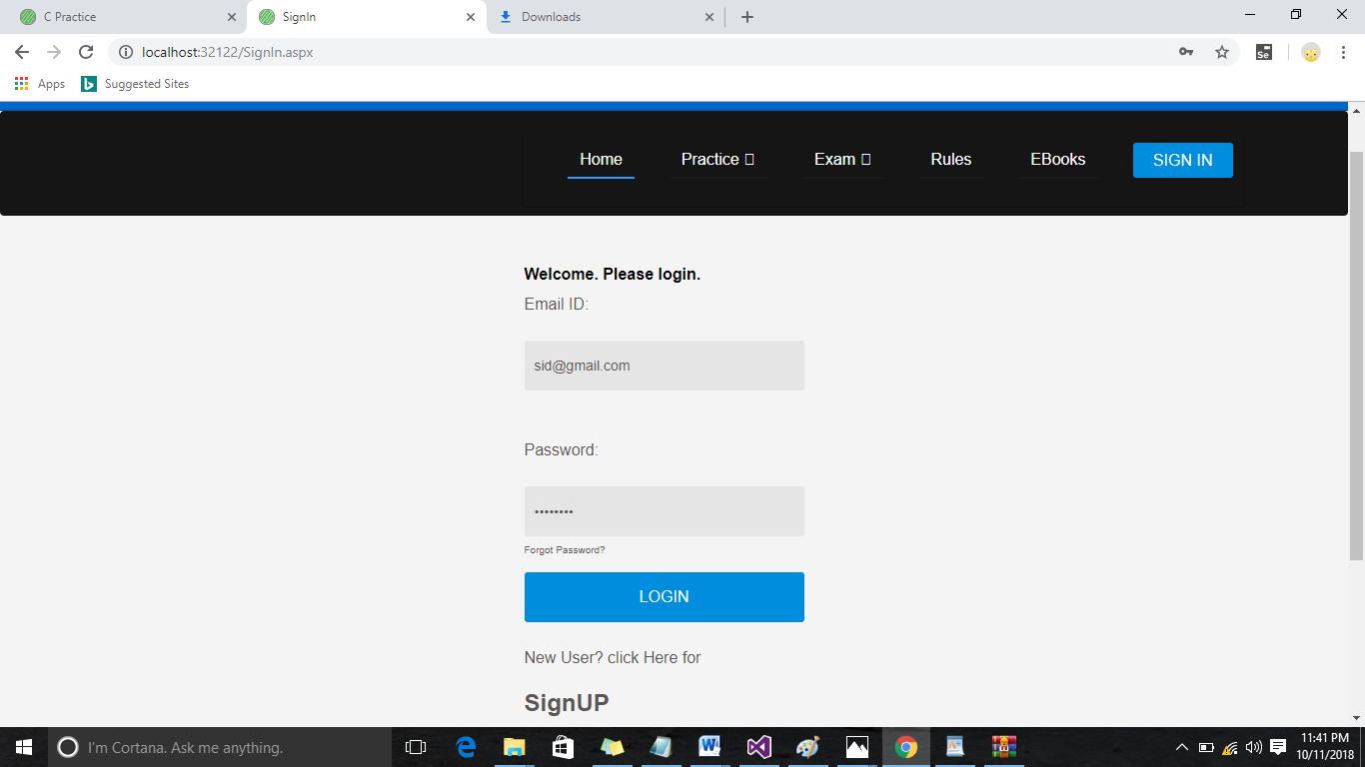

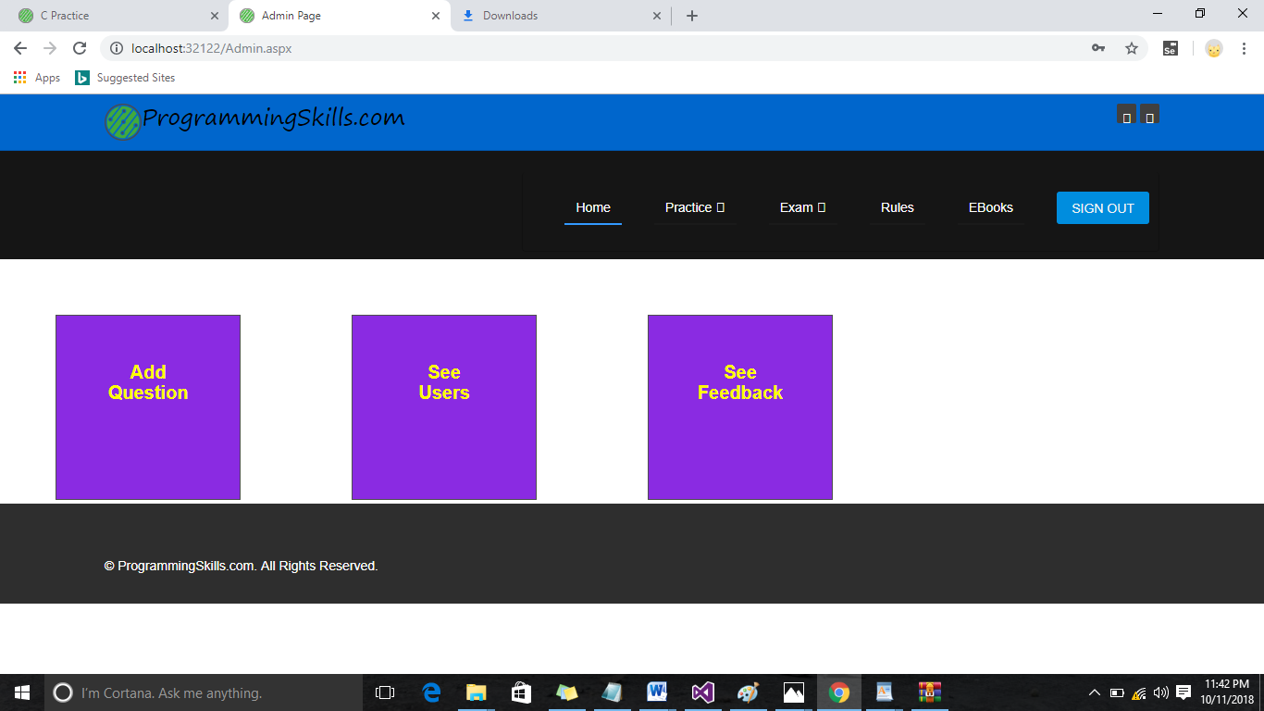

1. Add Questions Page:

<%@ Page Title="" Language="C#" MasterPageFile="~/MasterPage2.master" AutoEventWireup="true" CodeFile="AddQuestions.aspx.cs" Inherits="AddQuestions" %>

<asp:Content ID="Content1" ContentPlaceHolderID="title" Runat="Server">

</asp:Content>

<asp:Content ID="Content2" ContentPlaceHolderID="head" Runat="Server">

<style type="text/css">

.txtbox

{

position:absolute;

left:300px;

padding-right:200px;

}

#d1

{

left:-400px;

}

#d2

{

left:-800px;

}

</style>

</asp:Content>

<asp:Content ID="Content3" ContentPlaceHolderID="body" Runat="Server">

<asp:Button ID="Button1" runat="server" Text="Admin Page"

onclick="Button1_Click" />

&nbsp;&nbsp;&nbsp;&nbsp;&nbsp;&nbsp;&nbsp;&nbsp;&nbsp;&nbsp;&nbsp;&nbsp;&nbsp;&nbsp;&nbsp;&nbsp;&nbsp;&nbsp;&nbsp;&nbsp;&nbsp;&nbsp;&nbsp;&nbsp;&nbsp;&nbsp;&nbsp;&nbsp;&nbsp;&nbsp;&nbsp;&nbsp;&nbsp;&nbsp;&nbsp;&nbsp;&nbsp;&nbsp;&nbsp;&nbsp;&nbsp;&nbsp;&nbsp;&nbsp;&nbsp;&nbsp;

<div id = "d2">

<h2 style="color:Black; left:250px;">Select the subject</h2>

<br />

&nbsp;&nbsp;&nbsp;&nbsp;&nbsp;&nbsp;&nbsp;&nbsp;&nbsp;&nbsp;&nbsp;&nbsp;&nbsp;&nbsp;&nbsp;&nbsp;&nbsp;&nbsp;&nbsp;&nbsp;&nbsp;&nbsp;&nbsp;&nbsp;&nbsp;&nbsp;&nbsp;&nbsp;&nbsp;&nbsp;&nbsp;&nbsp;&nbsp;&nbsp;&nbsp;&nbsp;&nbsp;&nbsp;&nbsp;&nbsp;&nbsp;&nbsp;&nbsp;&nbsp;&nbsp;&nbsp;

<asp:DropDownList ID="DropDownList1" runat="server"

onselectedindexchanged="DropDownList1_SelectedIndexChanged"

AutoPostBack="True">

<asp:ListItem>(Select Subjects)</asp:ListItem>

<asp:ListItem>C</asp:ListItem>

<asp:ListItem>C++</asp:ListItem>

<asp:ListItem>Java</asp:ListItem>

<asp:ListItem>JavaScript</asp:ListItem>

<asp:ListItem>MySql</asp:ListItem>

<asp:ListItem>C#</asp:ListItem>

</asp:DropDownList><br /><br />

<h2><asp:Label ID="Label1" runat="server" Text="You are entering Questions in "

Visible="False"></asp:Label>

<asp:Label ID="Label2" runat="server" Text=""></asp:Label></h2>

</div>

<br />

<br />

<div id="d1">

&nbsp;&nbsp;&nbsp;&nbsp;&nbsp;&nbsp;&nbsp;

&nbsp;&nbsp;&nbsp;&nbsp;&nbsp;&nbsp;&nbsp;

&nbsp;&nbsp;&nbsp;&nbsp;&nbsp;&nbsp;&nbsp;

&nbsp;&nbsp;&nbsp;&nbsp;&nbsp;&nbsp;&nbsp;Question:<asp:TextBox ID="TextBox1" runat="server" CssClass="txtbox"

TextMode="MultiLine"></asp:TextBox><br />

<br />

<br />

<br />

&nbsp;&nbsp;&nbsp;&nbsp;&nbsp;&nbsp;&nbsp;

&nbsp;&nbsp;&nbsp;&nbsp;&nbsp;&nbsp;&nbsp;

&nbsp;&nbsp;&nbsp;&nbsp;&nbsp;&nbsp;&nbsp;

&nbsp;&nbsp;&nbsp;&nbsp;&nbsp;&nbsp;&nbsp;Option1:<asp:TextBox ID="TextBox2" runat="server" CssClass="txtbox"></asp:TextBox>

<br />

<br />

&nbsp;&nbsp;&nbsp;&nbsp;&nbsp;&nbsp;&nbsp;

&nbsp;&nbsp;&nbsp;&nbsp;&nbsp;&nbsp;&nbsp;

&nbsp;&nbsp;&nbsp;&nbsp;&nbsp;&nbsp;&nbsp;

&nbsp;&nbsp;&nbsp;&nbsp;&nbsp;&nbsp;&nbsp;Option2:<asp:TextBox ID="TextBox3" runat="server" CssClass="txtbox"></asp:TextBox>

<br /><br />

&nbsp;&nbsp;&nbsp;&nbsp;&nbsp;&nbsp;&nbsp;

&nbsp;&nbsp;&nbsp;&nbsp;&nbsp;&nbsp;&nbsp;

&nbsp;&nbsp;&nbsp;&nbsp;&nbsp;&nbsp;&nbsp;

&nbsp;&nbsp;&nbsp;&nbsp;&nbsp;&nbsp;&nbsp;Option3:<asp:TextBox ID="TextBox4" runat="server" CssClass="txtbox"></asp:TextBox>

<br /><br />

&nbsp;&nbsp;&nbsp;&nbsp;&nbsp;&nbsp;&nbsp;

&nbsp;&nbsp;&nbsp;&nbsp;&nbsp;&nbsp;&nbsp;

&nbsp;&nbsp;&nbsp;&nbsp;&nbsp;&nbsp;&nbsp;

&nbsp;&nbsp;&nbsp;&nbsp;&nbsp;&nbsp;&nbsp;Option4:<asp:TextBox ID="TextBox5" runat="server" CssClass="txtbox"></asp:TextBox>

<br /><br />

&nbsp;&nbsp;&nbsp;&nbsp;&nbsp;&nbsp;&nbsp;

&nbsp;&nbsp;&nbsp;&nbsp;&nbsp;&nbsp;&nbsp;

&nbsp;&nbsp;&nbsp;&nbsp;&nbsp;&nbsp;&nbsp;

&nbsp;&nbsp;&nbsp;&nbsp;&nbsp;&nbsp;&nbsp;Answer(in number):<asp:TextBox ID="TextBox6" runat="server" CssClass="txtbox"></asp:TextBox>

<br /><br />

&nbsp;&nbsp;&nbsp;&nbsp;&nbsp;&nbsp;&nbsp;

&nbsp;&nbsp;&nbsp;&nbsp;&nbsp;&nbsp;&nbsp;

&nbsp;&nbsp;&nbsp;&nbsp;&nbsp;&nbsp;&nbsp;

&nbsp;&nbsp;&nbsp;&nbsp;&nbsp;&nbsp;&nbsp;

&nbsp;&nbsp;&nbsp;&nbsp;&nbsp;&nbsp;&nbsp;&nbsp;&nbsp;&nbsp;&nbsp;&nbsp;&nbsp;&nbsp;&nbsp;&nbsp;&nbsp;&nbsp;&nbsp;&nbsp;&nbsp;&nbsp;&nbsp;&nbsp;&nbsp;&nbsp;&nbsp;&nbsp;&nbsp;&nbsp;&nbsp;&nbsp;&nbsp;&nbsp;&nbsp;&nbsp;&nbsp;&nbsp;&nbsp;&nbsp;&nbsp;&nbsp;&nbsp;&nbsp;&nbsp;&nbsp;

<asp:Button ID="AddQues" runat="server" Text="Add" onclick="AddQues_Click" />

</div>

</asp:Content>

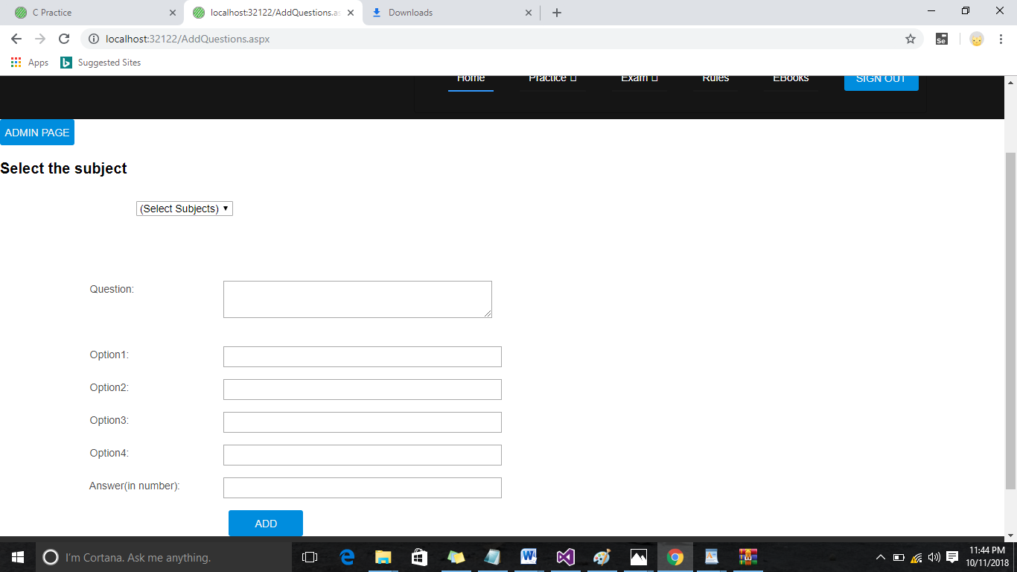

* DataBase Page:

1. Registration:

Design-

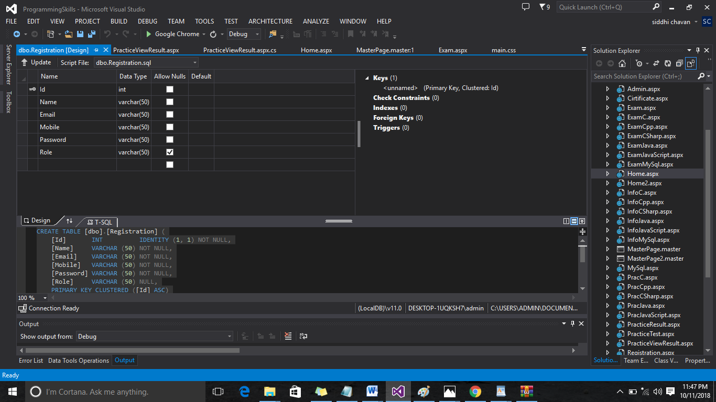

Data-

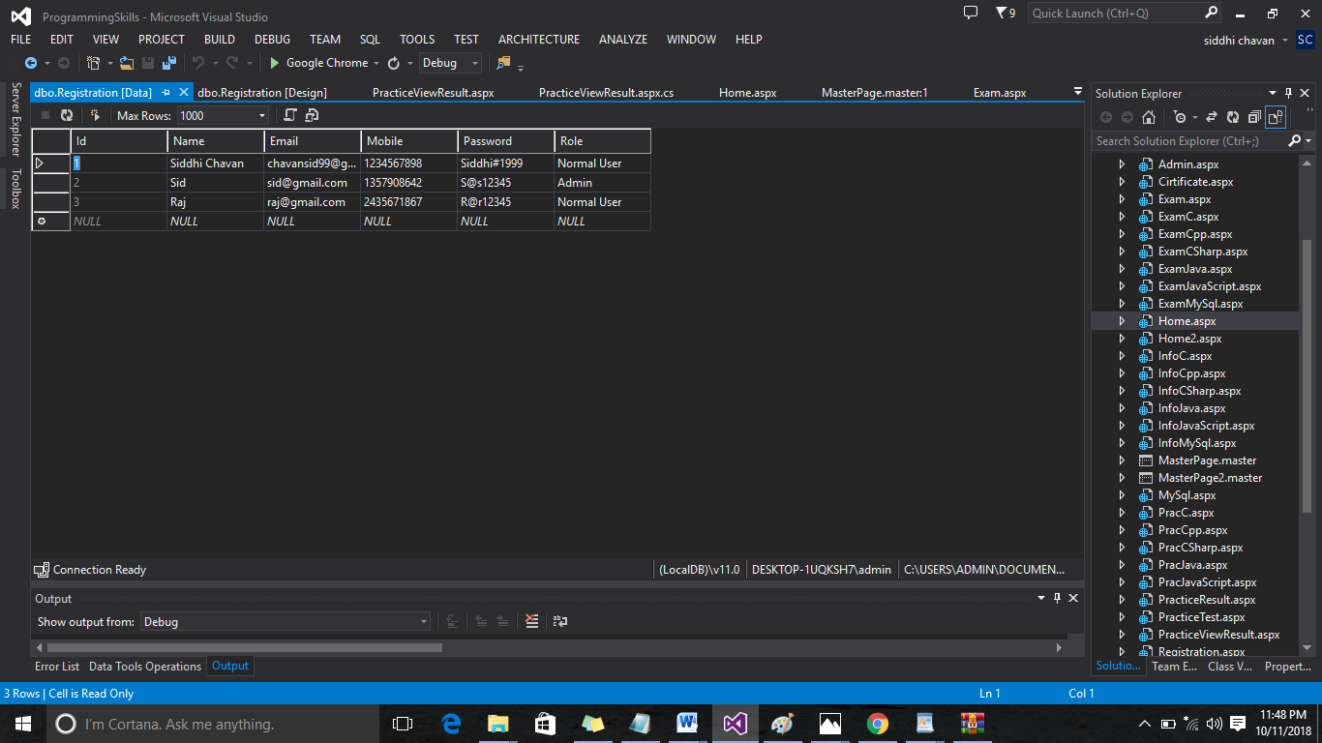

1. C:

Design-

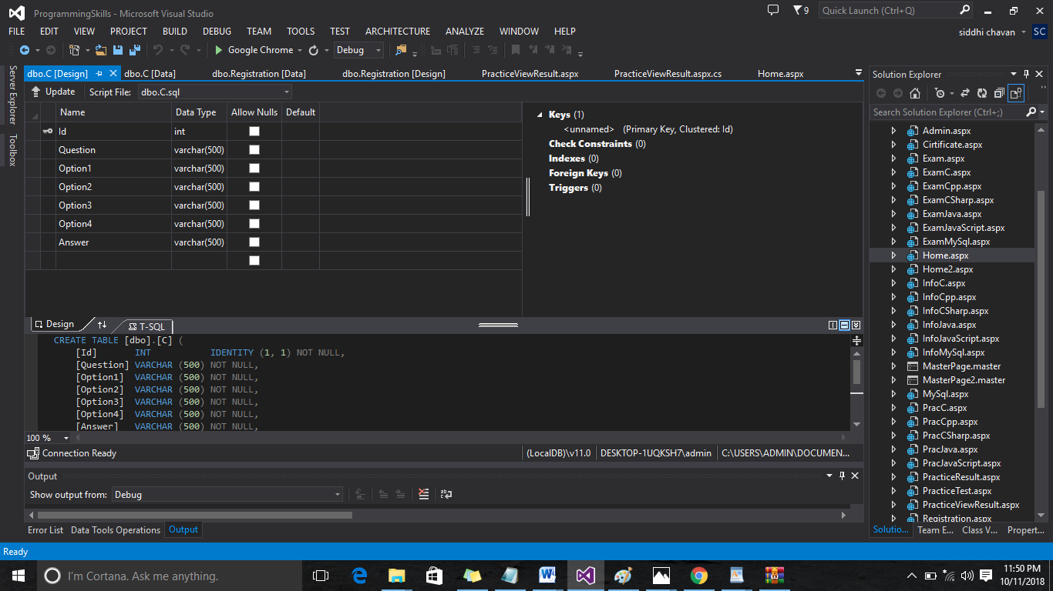

Data-

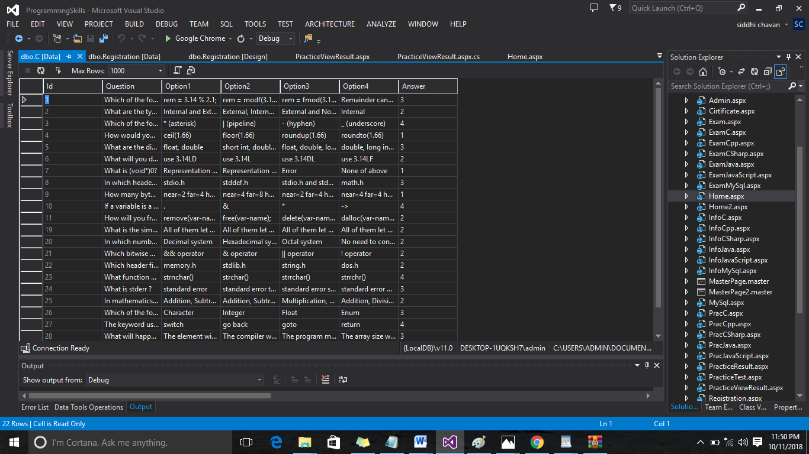

1. Answer:

Design-

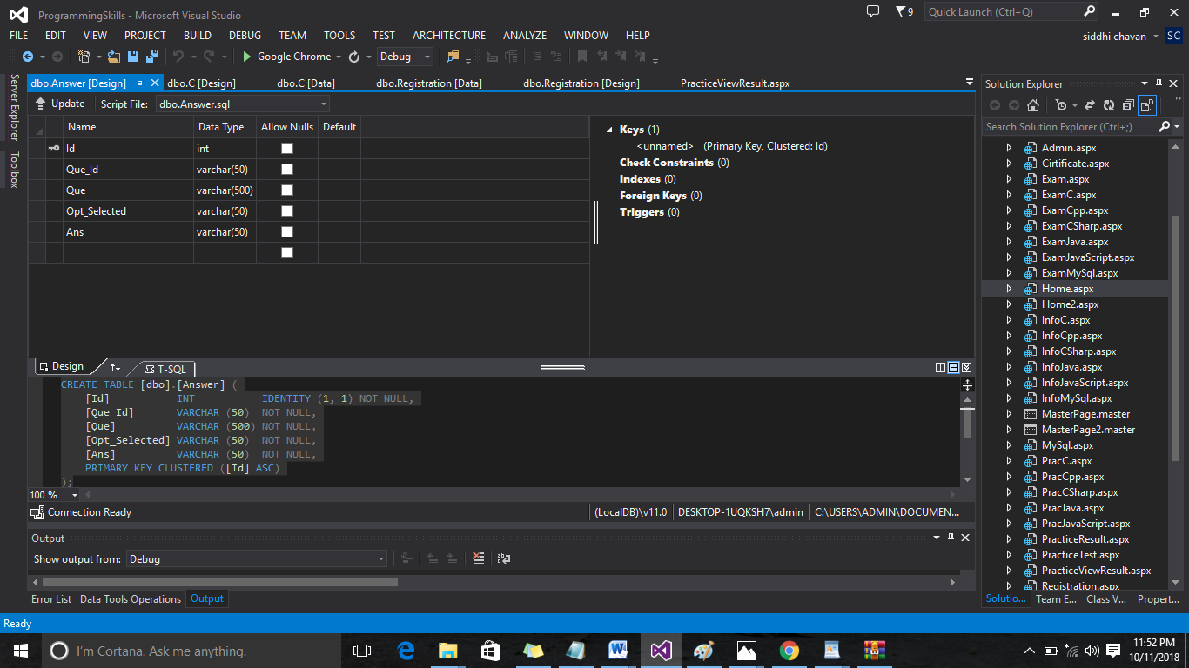

Data-

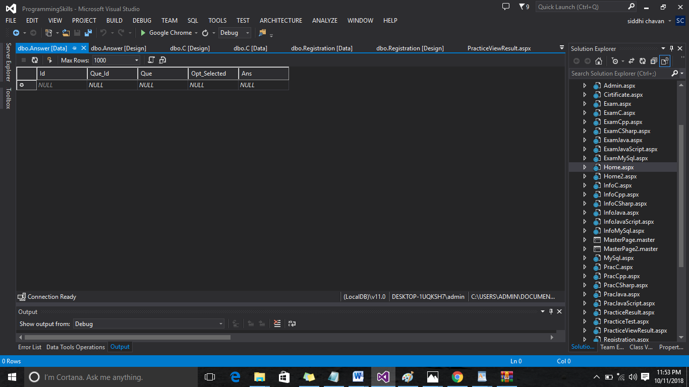

* Conclusion:

Our project is only a humble venture to satisfy the needs to manage their project work. Several users friendly coding have also adopted.

1. We designed user interface related to system.
2. We include features and operations in detail, including screen layouts.
3. We understand the problem domain and produced a model of the system, which describes operation that can be performed on the system.
4. We define the problem on which we working in the project.

* Reference:
* Google for problem solving.
* <http://www.tutorialspoint.com/mysql/>
* <http://www.tutorialspoint.com/visualstudio/>
* <http://YouTube/how> to create database in visual studio/